* 1. TASK 1: USE INHERITANCE

Create table:

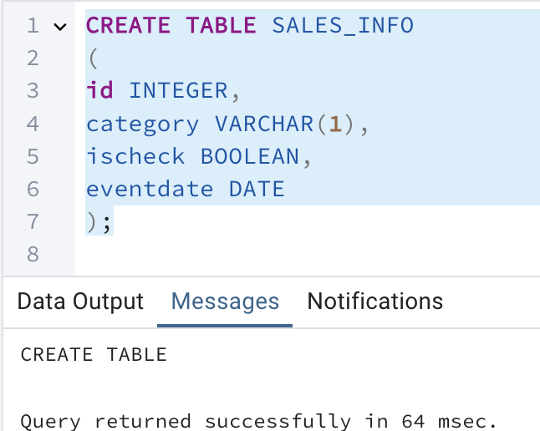

Apply partitioning by using inheritance:

1. Create 4-5 child tables with partitioning by eventdate column. One partition is one year.

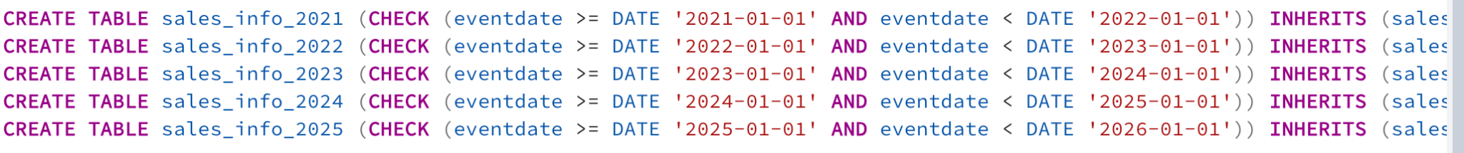

2. Create partition function for your tables:

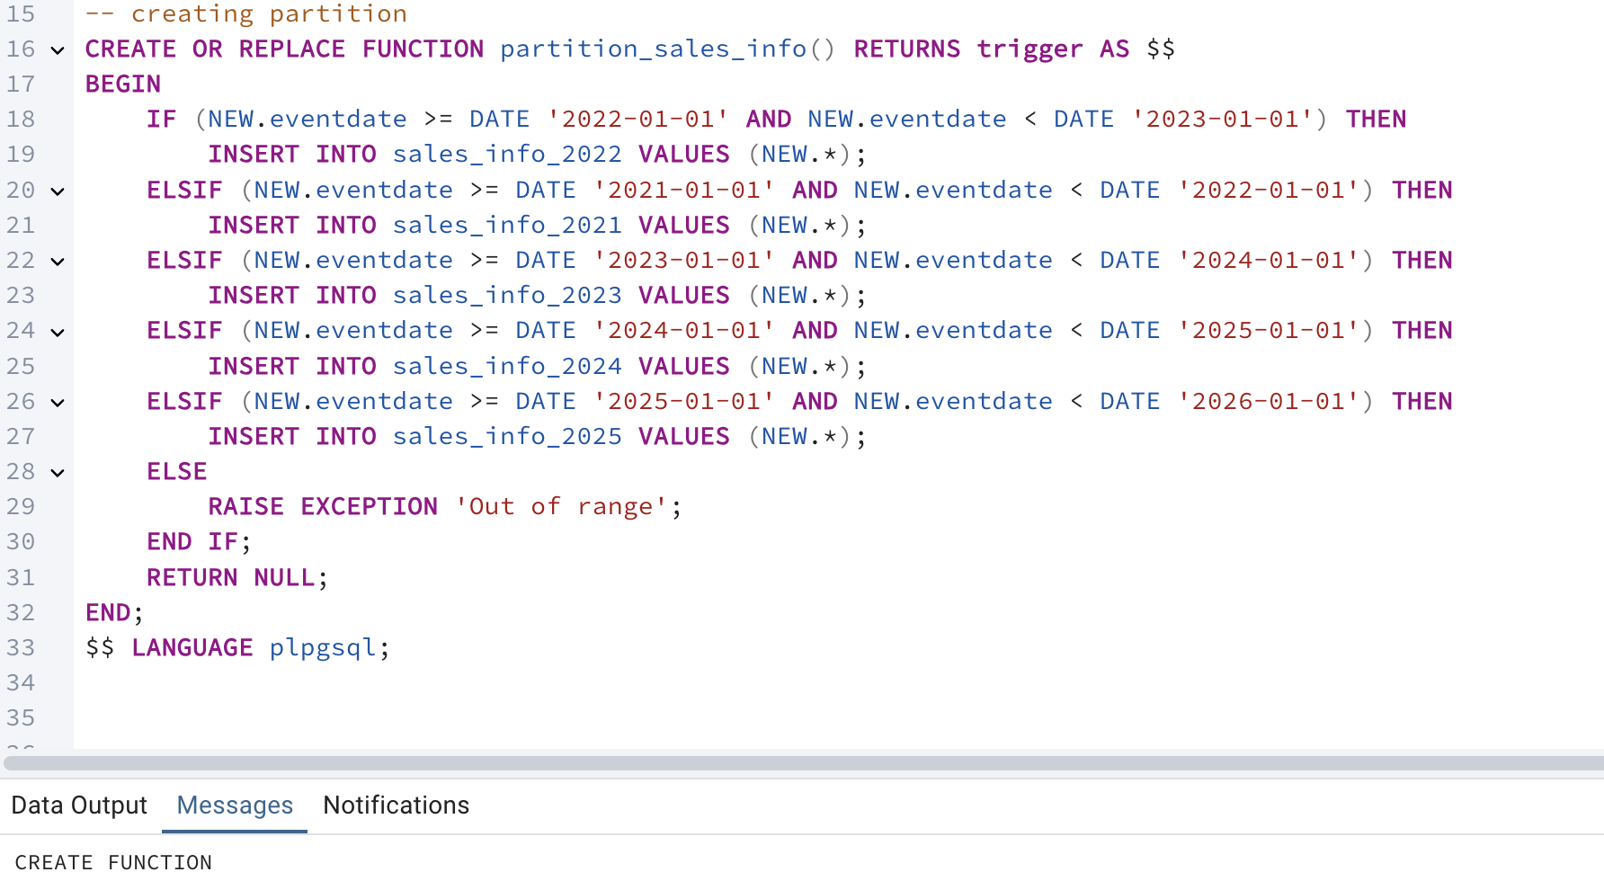

3. Create trigger for your function and tables:

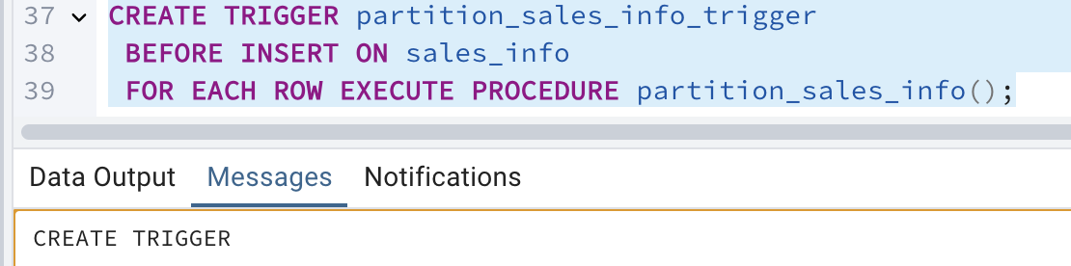

4. Generate test data and insert in SALES_INFO table:

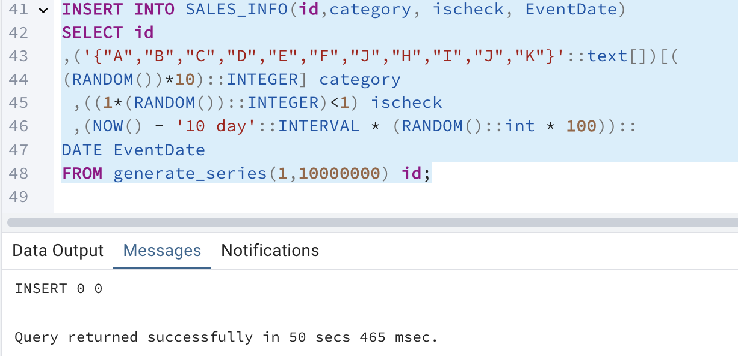

5. Update some rows in SALES_INFO and set another eventdate.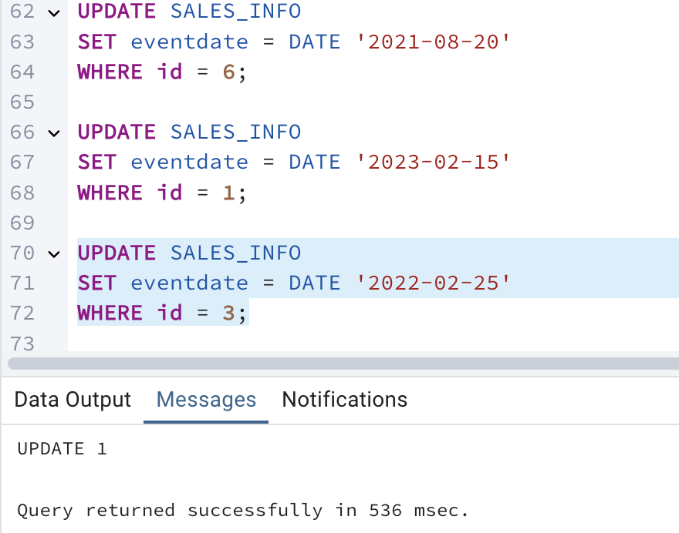

6. Create table SALES_INFO_SIMPLE with the same structure as SALES_INFO but without partitioning. Insert test data from the 5th step. Compare plans of different queries:

• Select all

• Select with range of dates

• Select exact date

• Count of all rows

• Count of rows with range of dates

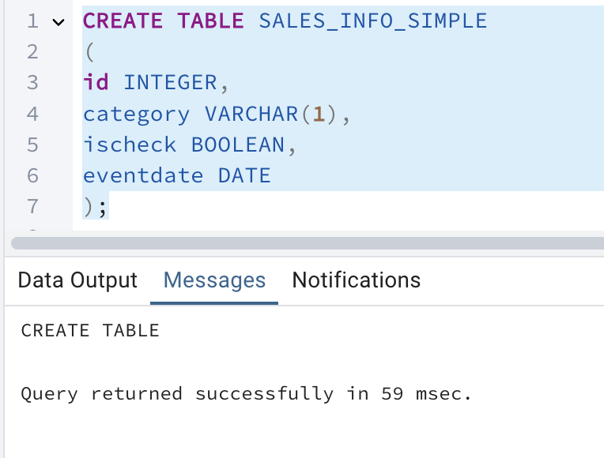

Inserting from first table into this one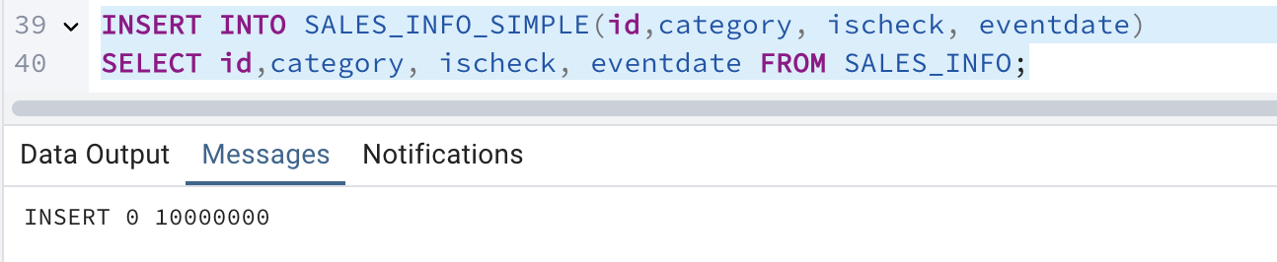

Comparing:

**EXPLAIN** **ANALYZE** **SELECT** * **FROM** SALES_INFO;

**EXPLAIN** **ANALYZE** **SELECT** * **FROM** SALES_INFO_SIMPLE;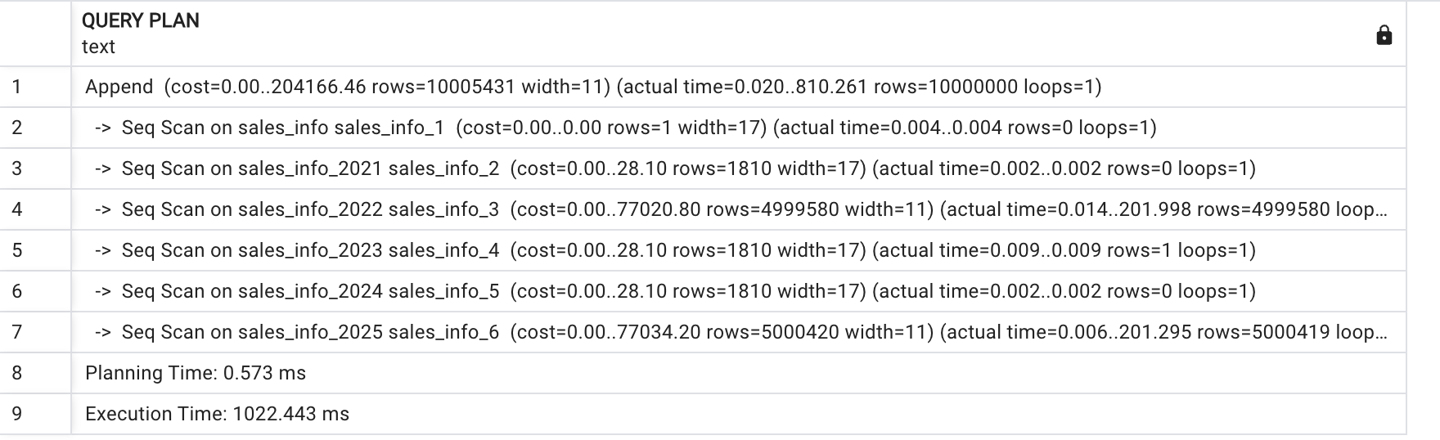

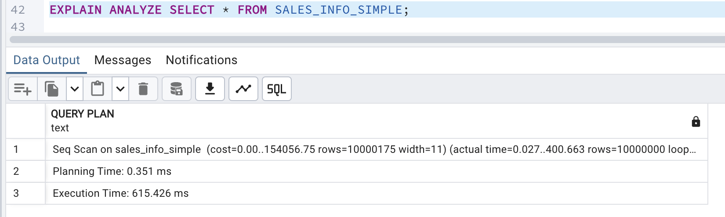

I compared the performance of a partitioned table and a non-partitioned table using the **EXPLAIN** **ANALYZE** **SELECT** * query. The partitioned table takes more execution time because it scans multiple partitions and merges the results. The non-partitioned table runs a single sequential scan, making it faster for full table scans.

The planning time for the partitioned table is little bit higher than that of the non-partitioned table

The non-partitioned table performs better in terms of execution time for full table scans, as it involves a single sequential scan.

-- select with range of dates

**EXPLAIN** **ANALYZE** **SELECT** * **FROM** SALES_INFO **WHERE** eventdate **BETWEEN** **'2024-01-01'** **AND** **'2024-12-31'**;

**EXPLAIN** **ANALYZE** **SELECT** * **FROM** SALES_INFO_SIMPLE **WHERE** eventdate **BETWEEN** **'2024-01-01'** **AND** **'2024-12-31'**;

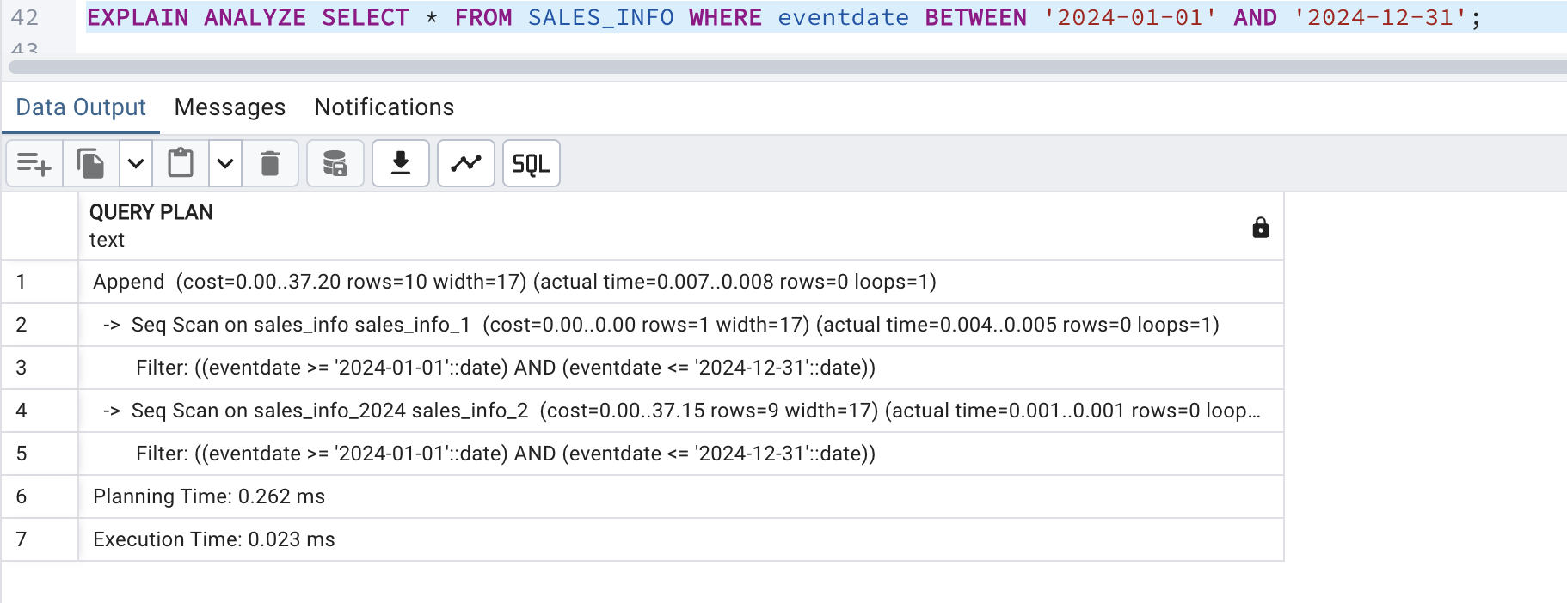

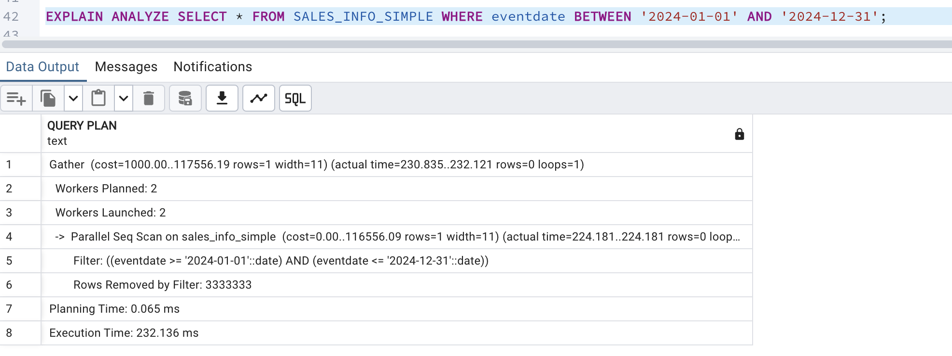

I tested a query with a date filter on a partitioned and a non-partitioned table. The partitioned table performed much faster because it scanned only the relevant partitions, reducing execution time. The non-partitioned table scanned the whole dataset, even with parallel execution. It is shows that partitioning is very effective for filtering queries on indexed columns like dates. It avoids scanning unnecessary data, making queries much faster.

-- Select exact date

**EXPLAIN** **ANALYZE** **SELECT** * **FROM** SALES_INFO **WHERE** eventdate = **'2023-08-15'**;

**EXPLAIN** **ANALYZE** **SELECT** * **FROM** SALES_INFO_SIMPLE **WHERE** eventdate = **'2023-08-15'**;

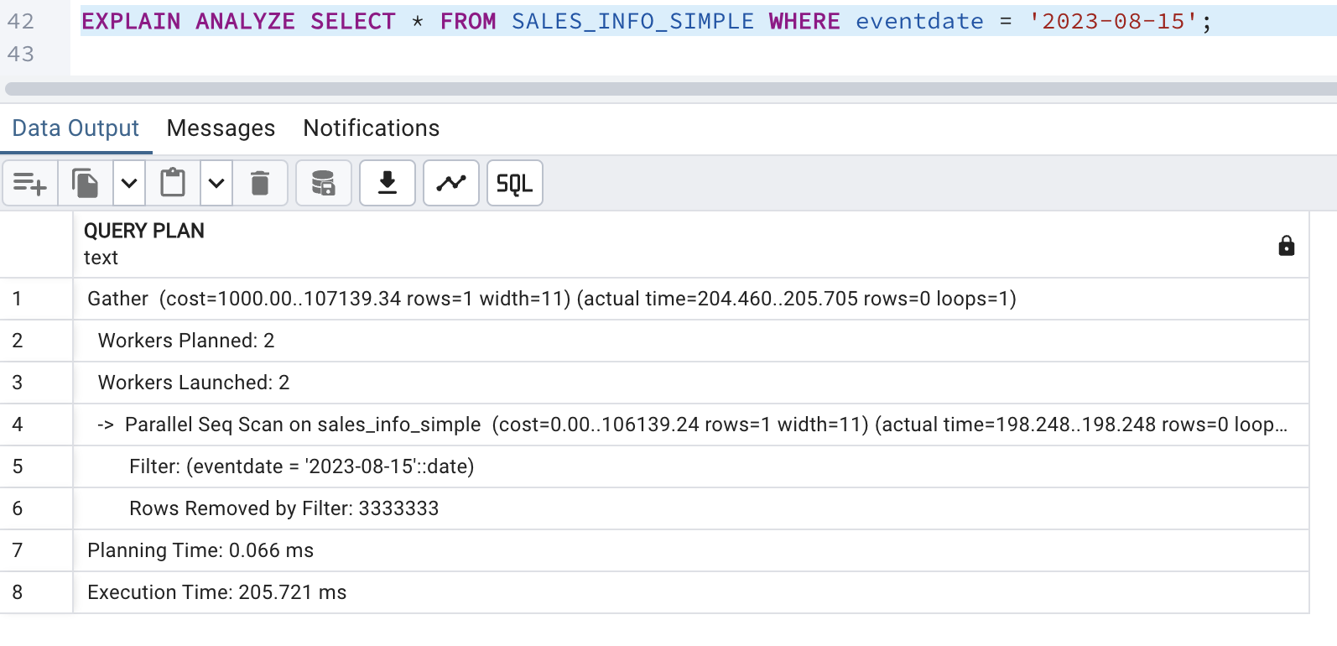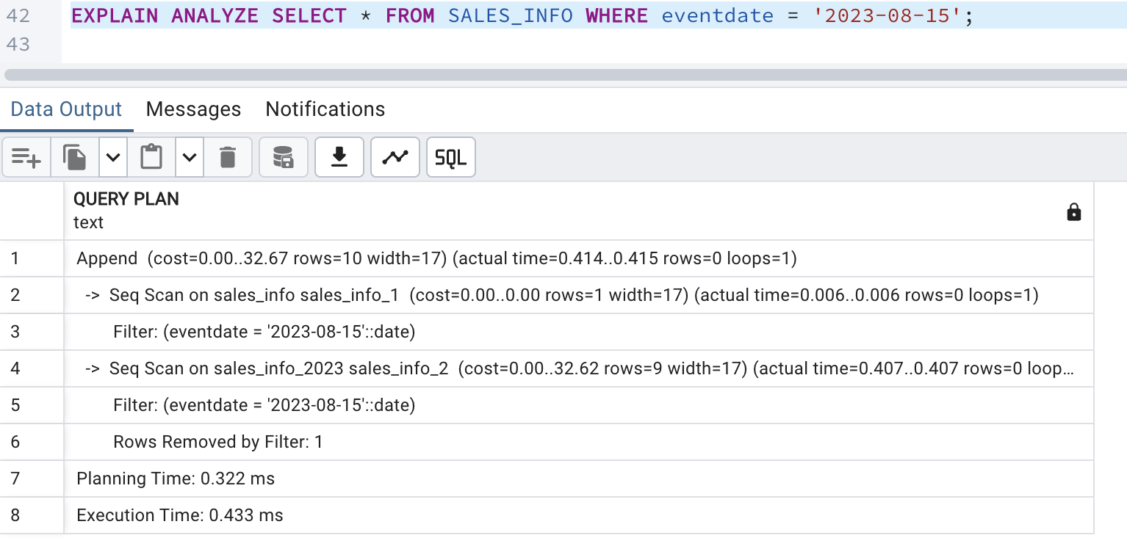

The partitioned table runs faster for the exact date query because it only looks at the needed partitions, reducing the data to scan. But it takes a bit more time to plan the query because it has to figure out which partitions to use. The partitioned table is more efficient as it scans just the relevant partition (sales_info_2023). On the other hand, the non-partitioned table scans the entire table, which takes more time since it has to go through more data.

**EXPLAIN** **ANALYZE** **SELECT** **COUNT**(*) **FROM** SALES_INFO;

**EXPLAIN** **ANALYZE** **SELECT** **COUNT**(*) **FROM** SALES_INFO_SIMPLE;

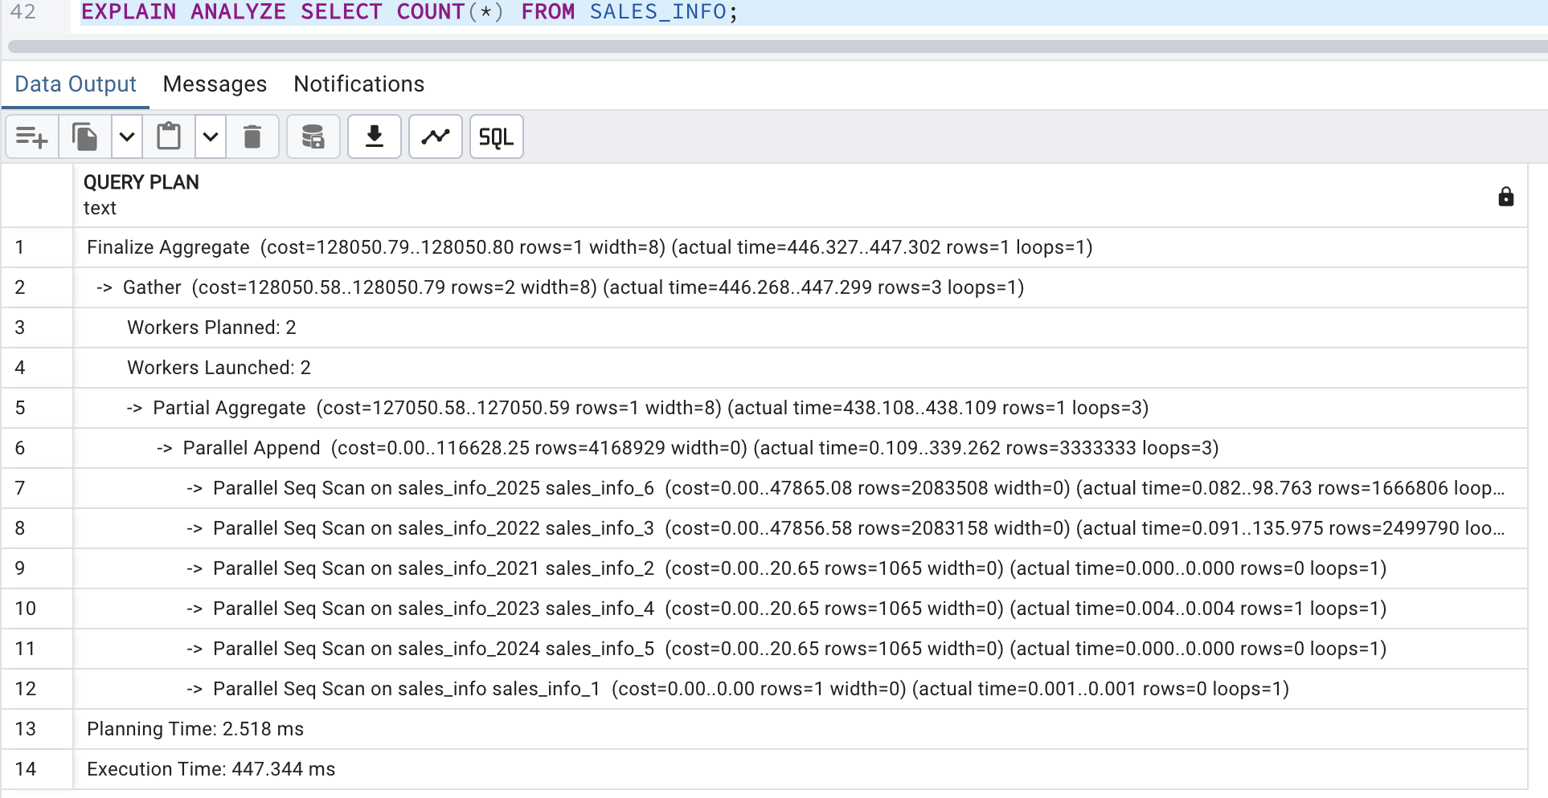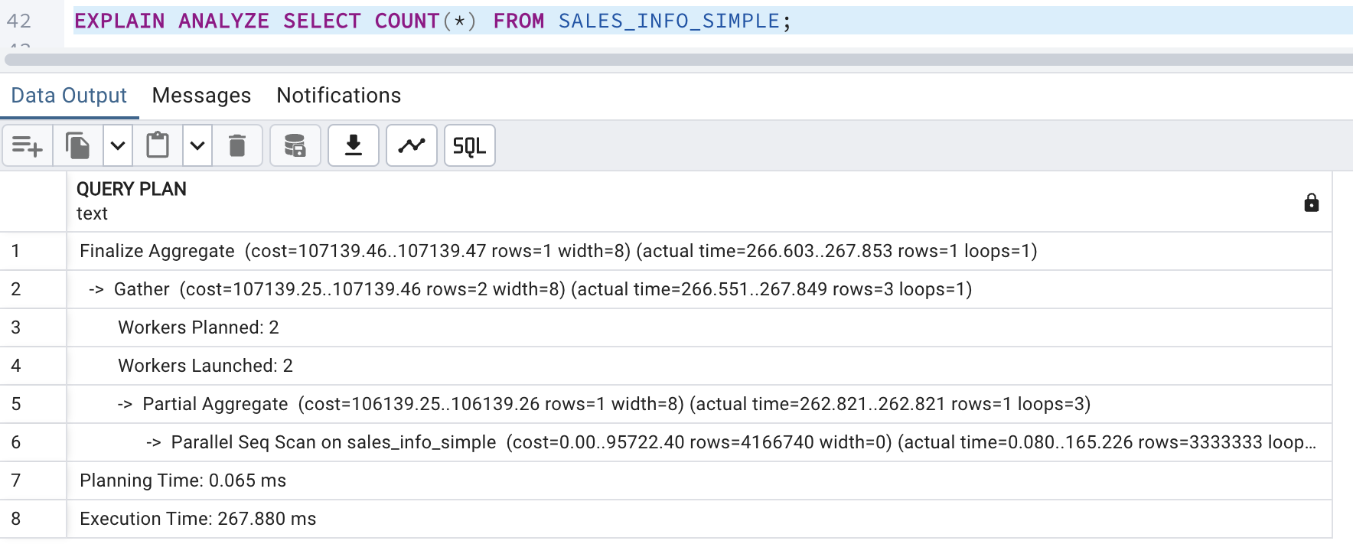

I tested the performance of the COUNT(*) query on both a partitioned and a non-partitioned table. The partitioned table took longer because it had to scan multiple partitions separately and then aggregate the results. Each partition was processed individually.

The non-partitioned table performed more faster because it scanned all the rows in a single sequential operation. This result shows that partitioning is not always beneficial, especially for aggregation queries like COUNT(*).

-- Count of rows with range of dates

**EXPLAIN** **ANALYZE** **SELECT** **COUNT**(*) **FROM** SALES_INFO **WHERE** eventdate **BETWEEN** **'2023-01-01'** **AND** **'2023-12-31'**;

**EXPLAIN** **ANALYZE** **SELECT** **COUNT**(*) **FROM** SALES_INFO_SIMPLE **WHERE** eventdate **BETWEEN** **'2023-01-01'** **AND** **'2023-12-31'**;

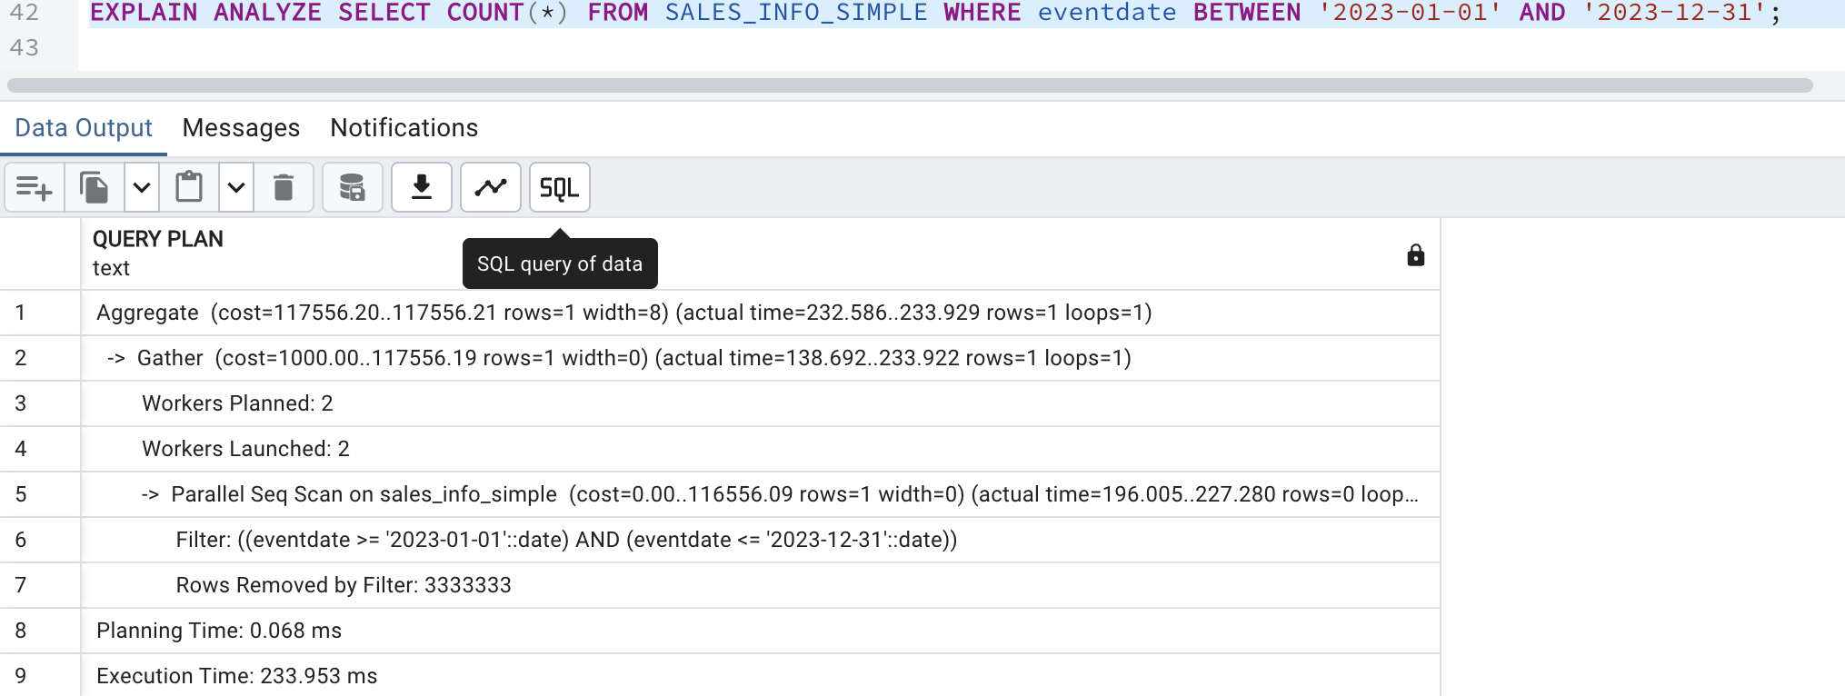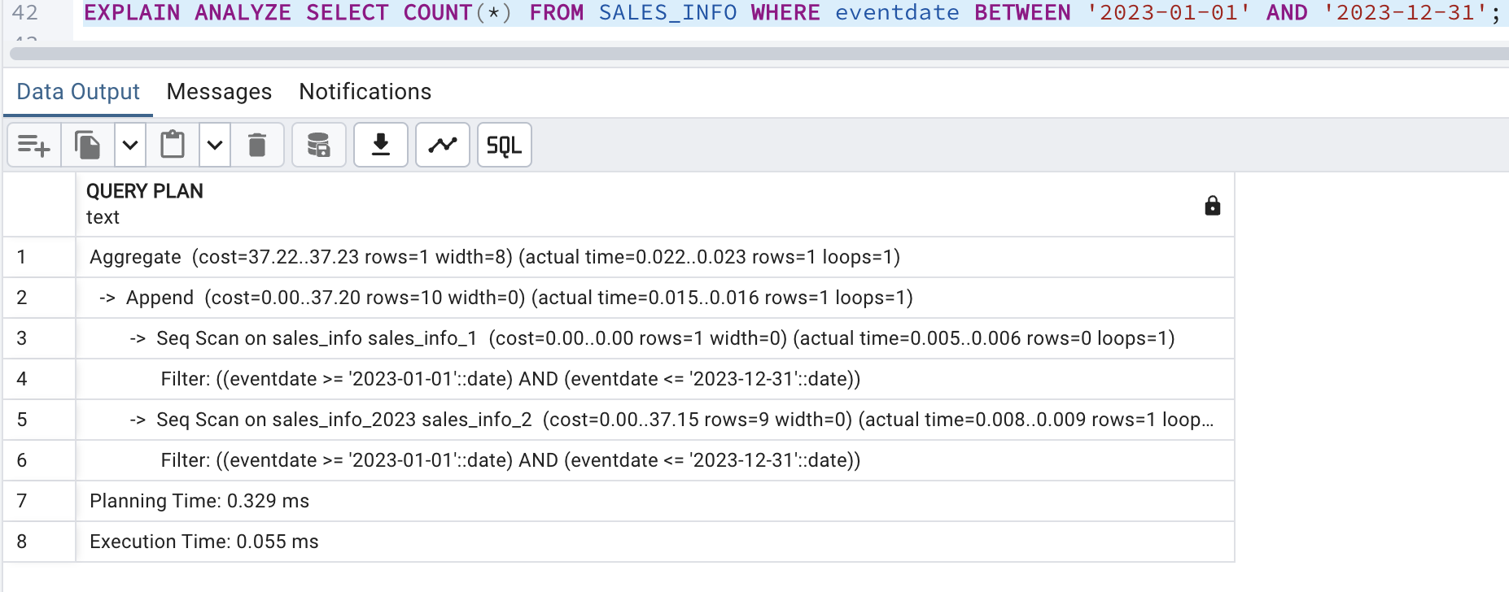

The SALES_INFO table has a significantly lower execution time for counting rows within a date range, as it only scans the relevant partitions. The non-partitioned table has a much higher execution time since it performs a full table scan and applies the date filter to all rows. The partitioned approach is more efficient for range queries because it scans only the necessary data segments.

I dropped the table sales_info_2021 and then created new table sales_info_3000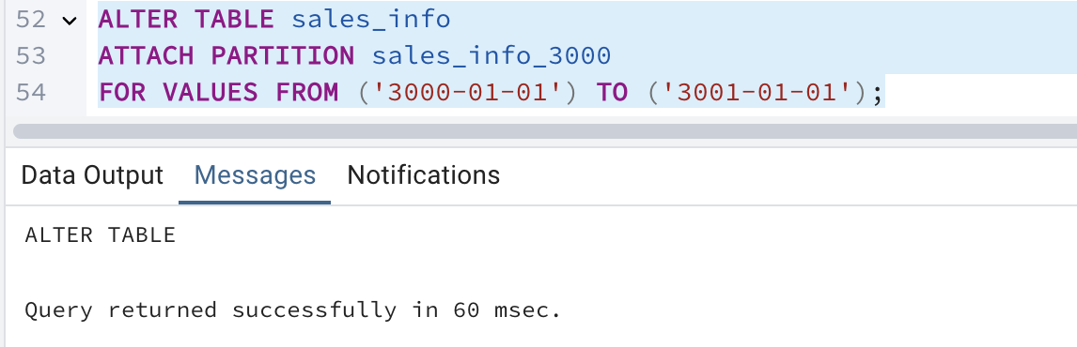

But it shows presios error.

Table is not partitioned, I partitioned by creating new table and it works

* 1. TASK2: USE DECLARATIVE PARTITIONING

1. Create the Parent Table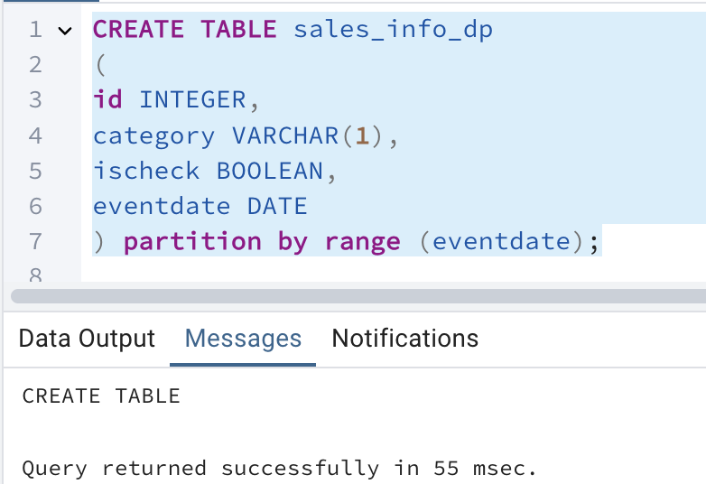

1. Create Child Tables 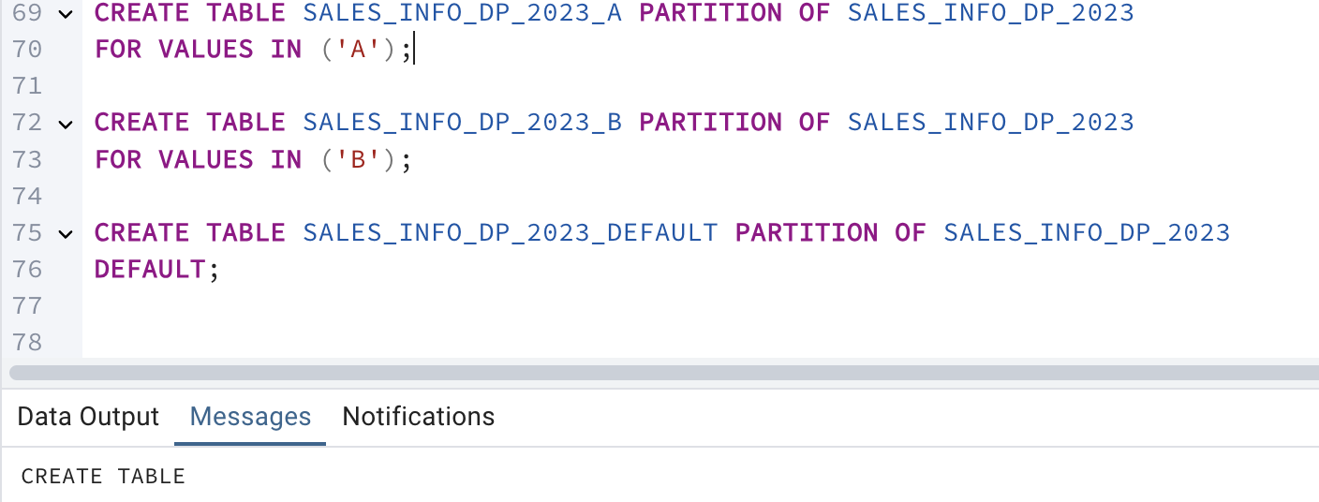

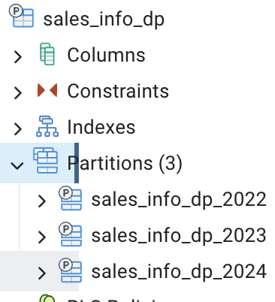

Same for 2022, 2024.

Now inserting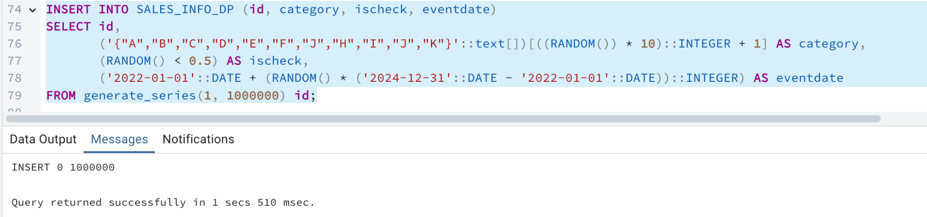

Updating only 1000 rows 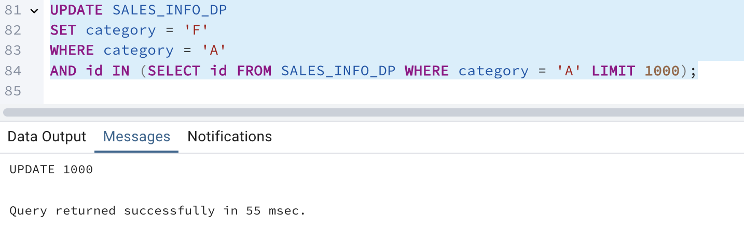

Select all for partitioning and non partitioning

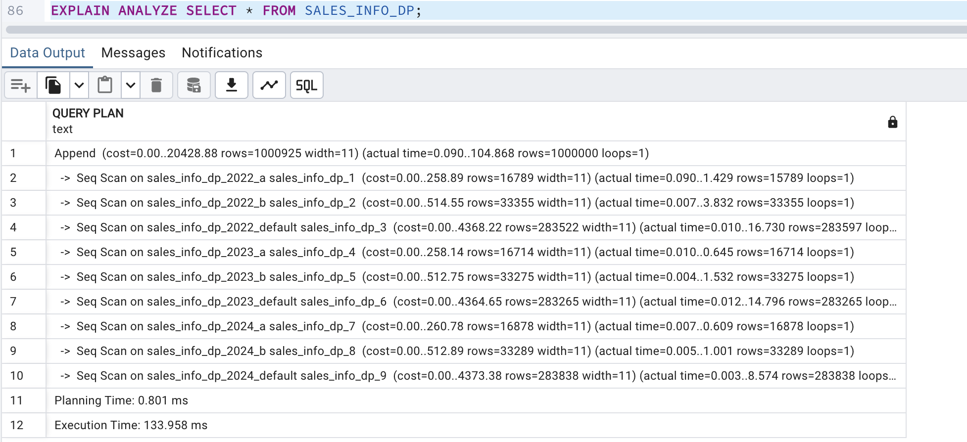

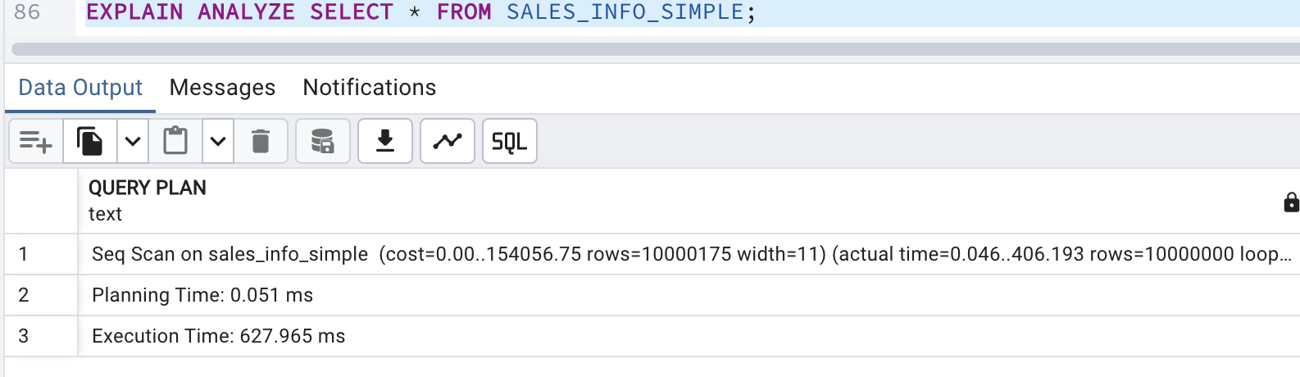

The execution plan comparison shows that the partitioned table performs sequential scans across multiple partitions, resulting in a lower execution time. In contrast, the non-partitioned table performs a single sequential scan, but with a higher execution time. This shows that partitioning can make queries faster, but for very large scans, the benefits may be smaller.

- select with range of dates

EXPLAIN ANALYZE SELECT * FROM SALES_INFO_DP WHERE eventdate BETWEEN '2024-06-01' AND '2024-12-31';

EXPLAIN ANALYZE SELECT * FROM SALES_INFO_SIMPLE WHERE eventdate BETWEEN '2024-06-01' AND '2024-12-31';

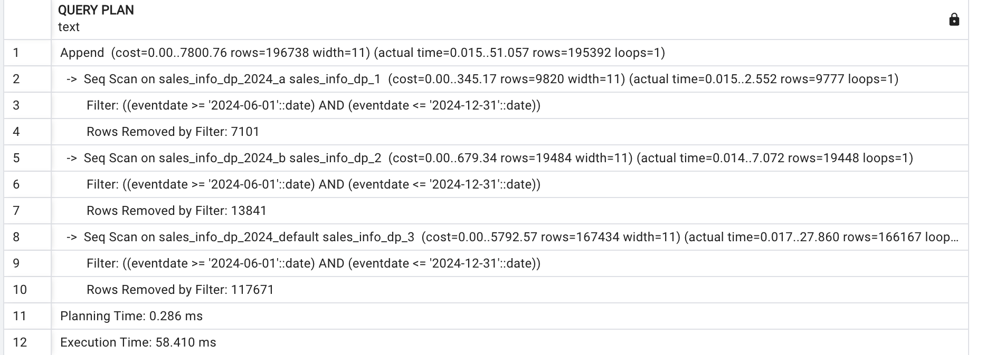

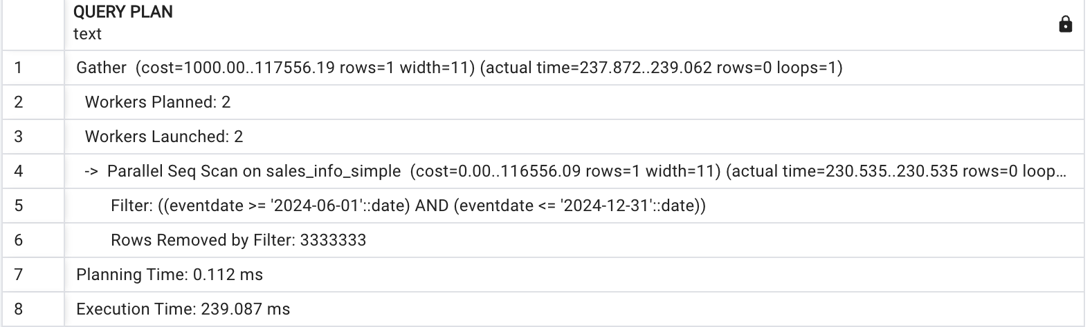

The execution plan comparison for the range date query shows that SALES_INFO_DP (partitioned table) performs sequential scans only on relevant partitions, resulting in a lower execution time. In contrast, SALES_INFO_SIMPLE performs a single sequential scan filtering the rows, with a significantly longer execution time. This means the efficiency of partition pruning in the partitioned table, which reduces the amount of data scanned and improves query performance for date ranges.

Select exact dates

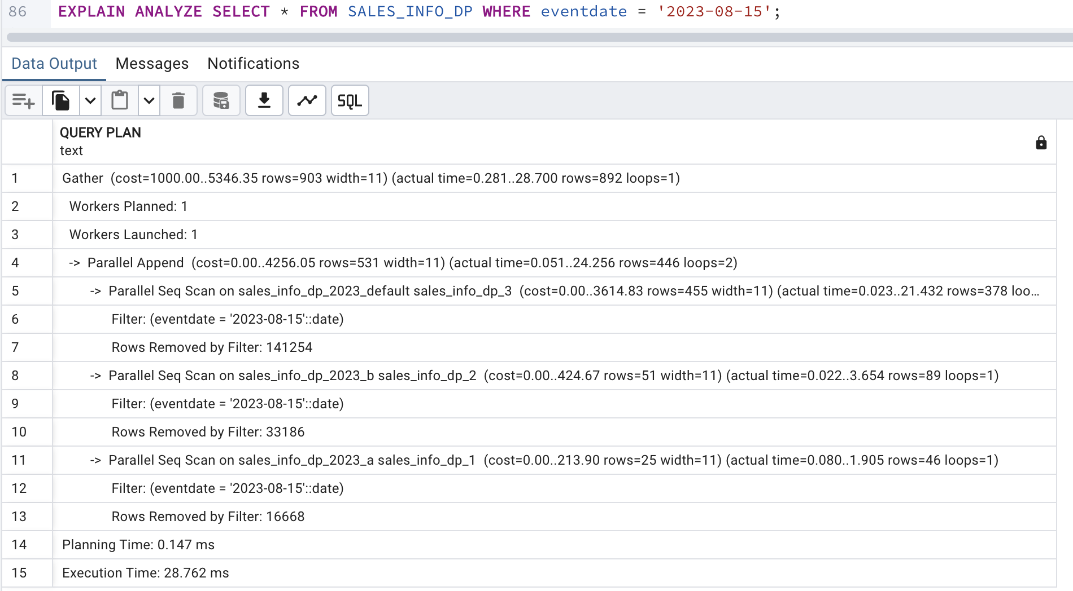

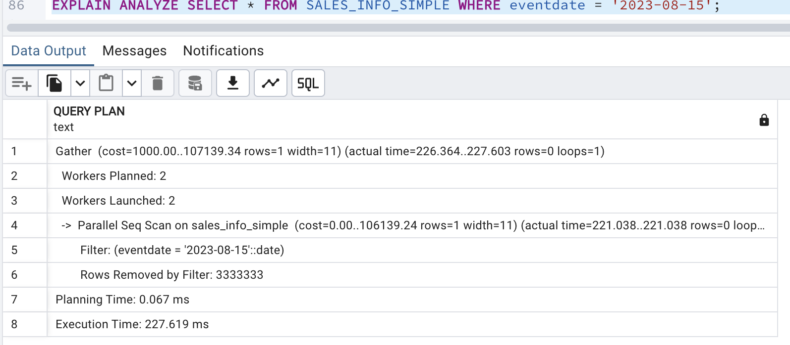

The execution plan comparison for the exact date query shows that SALES_INFO_DP uses parallel sequential scans on relevant partitions, resulting in a faster execution time

SALES_INFO_SIMPLE also uses parallel sequential scans, but it takes significantly longer because it scans the entire table instead of just the relevant partitions.

This indicates that partition pruning and parallel execution in the partitioned table provide a substantial performance advantage for queries on specific dates.

Select categories

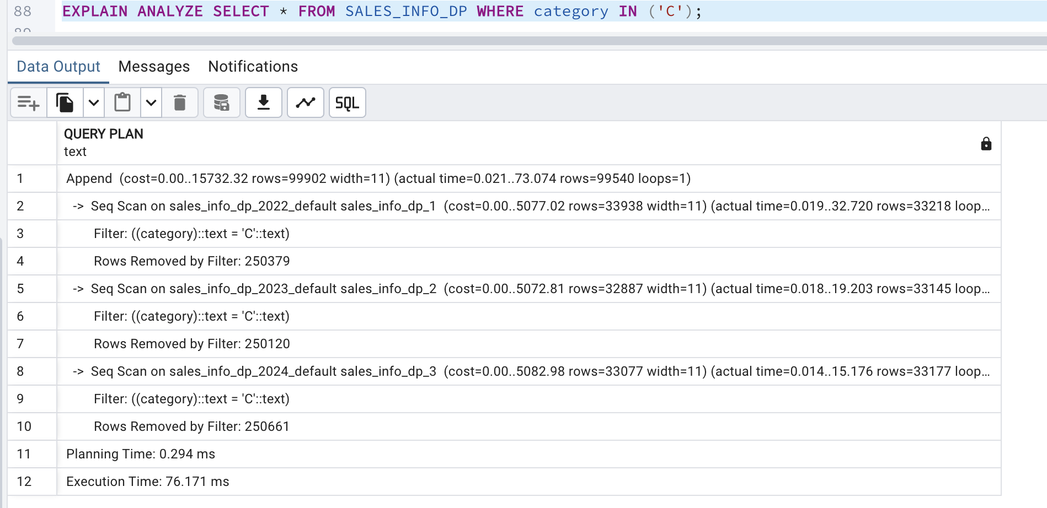

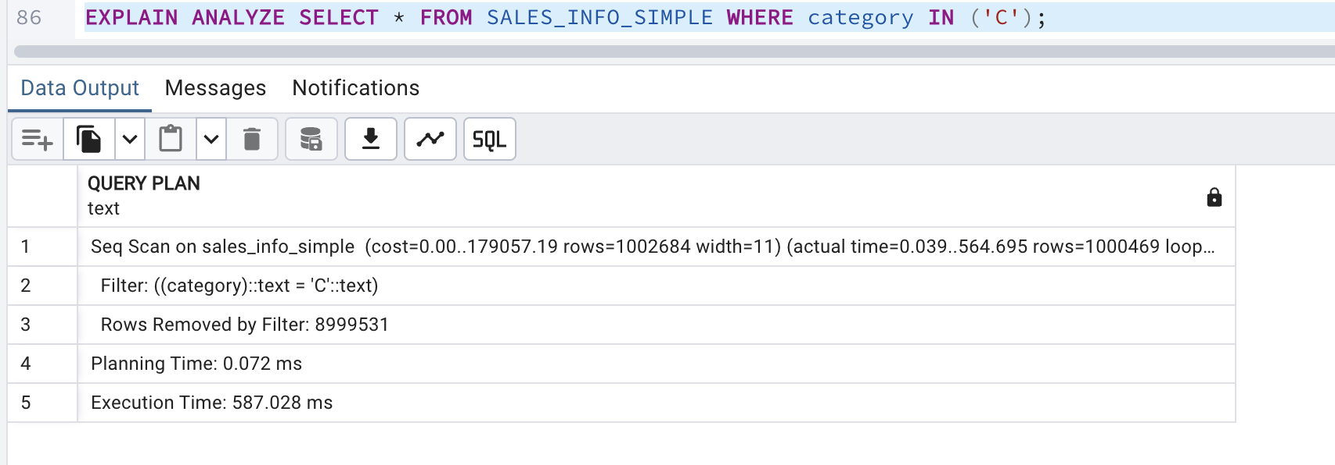

The execution plan comparison for selecting a specific category shows that SALES_INFO_DP performs sequential scans across relevant partitions, resulting in an execution time with low time In contrast, SALES_INFO_SIMPLE uses parallel sequential scans and takes significantly longer. This highlights the efficiency of partition pruning in reducing the amount of data scanned and improving query performance for category-based queries.

Select list of categories

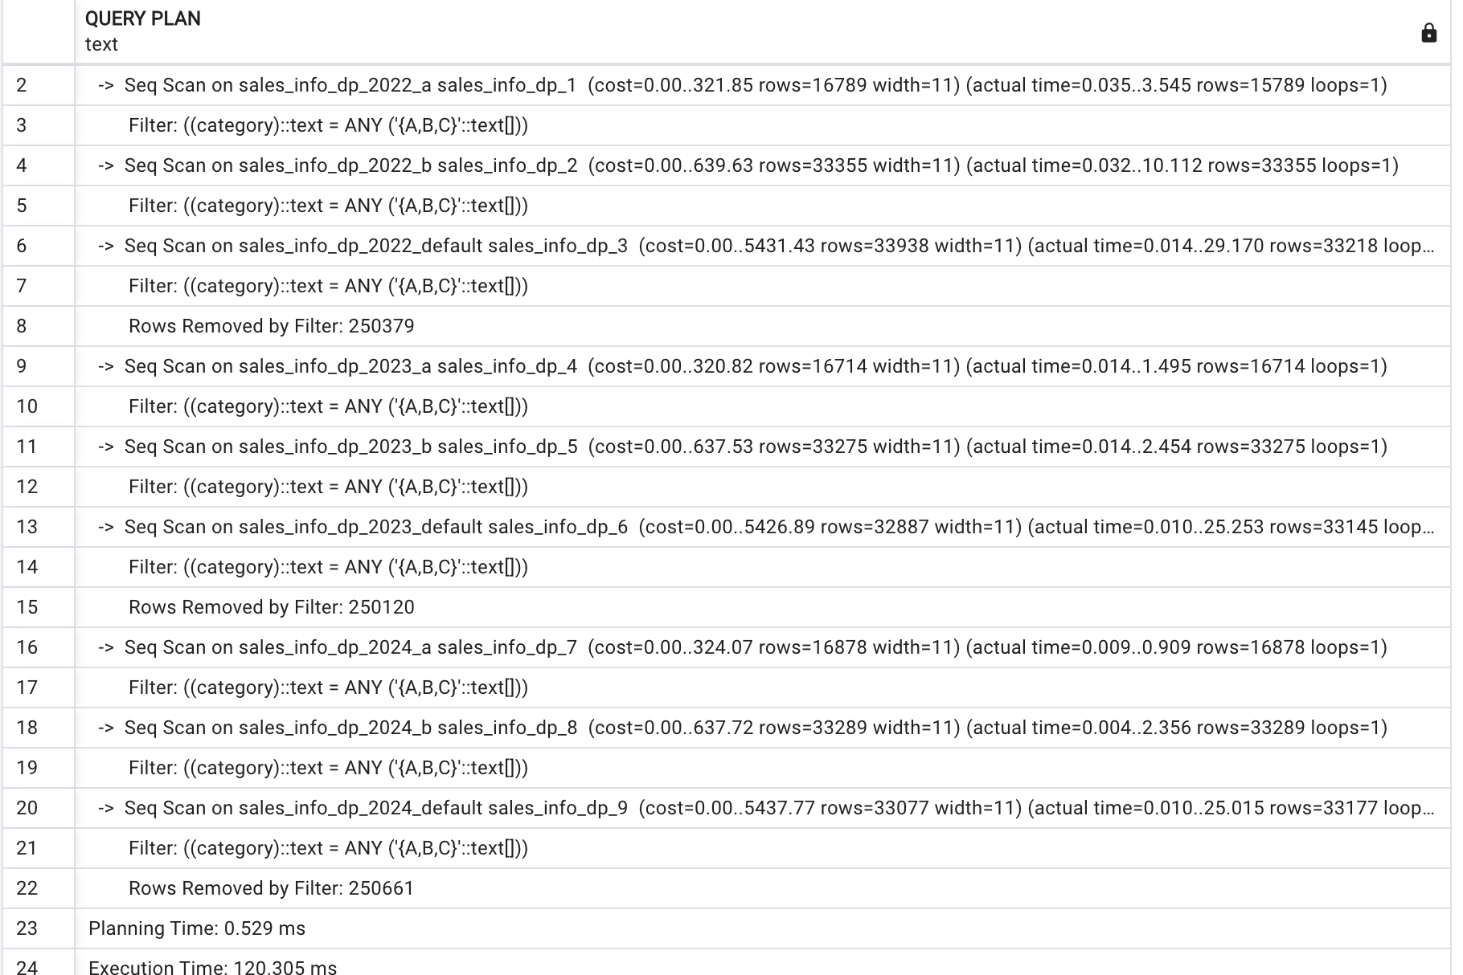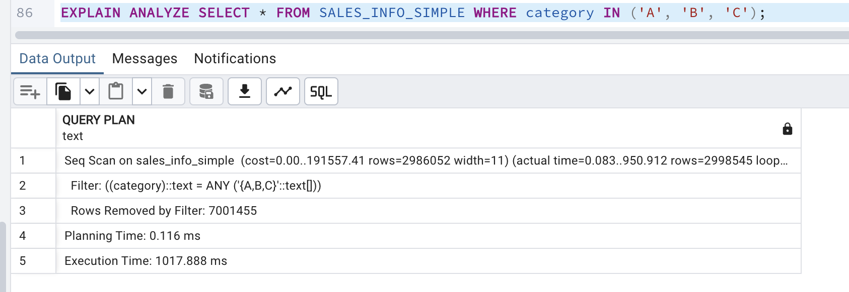

Partitioned table (SALES_INFO_DP) executes much faster than the non-partitioned table. The partitioned table scans only relevant partitions, reducing the number of rows processed. In contrast, the non-partitioned table scans the entire dataset, making execution significantly slower.

This confirms that partitioning improves query performance when filtering specific categories

**Select a List of Categories on an Exact Date**

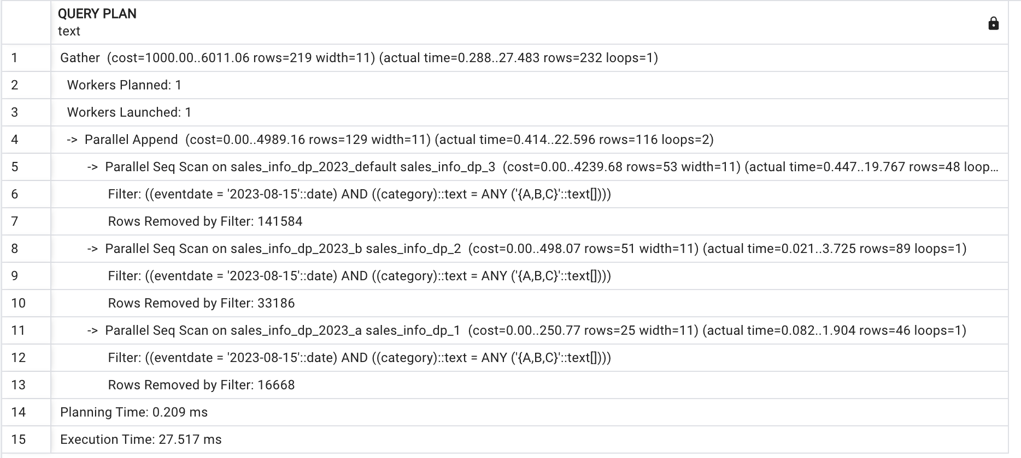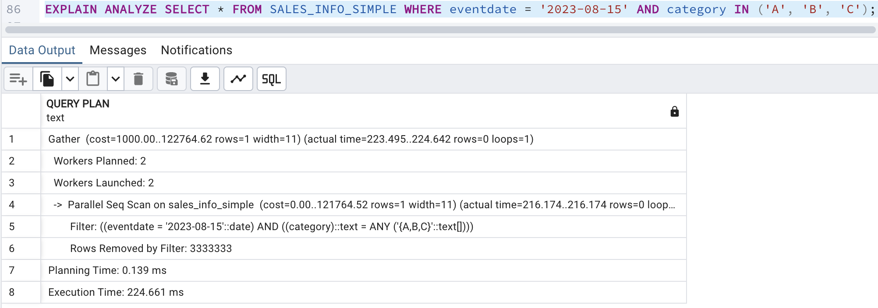

Query run much faster on the partitioned table (SALES_INFO_DP) with an execution time of 27.517 ms, compared to 224.661 ms on the non-partitioned table The partitioned table scans only relevant partitions reducing the number of rows processed. The non-partitioned table must scan the entire dataset leading to a much longer execution time.

**Count of All Rows**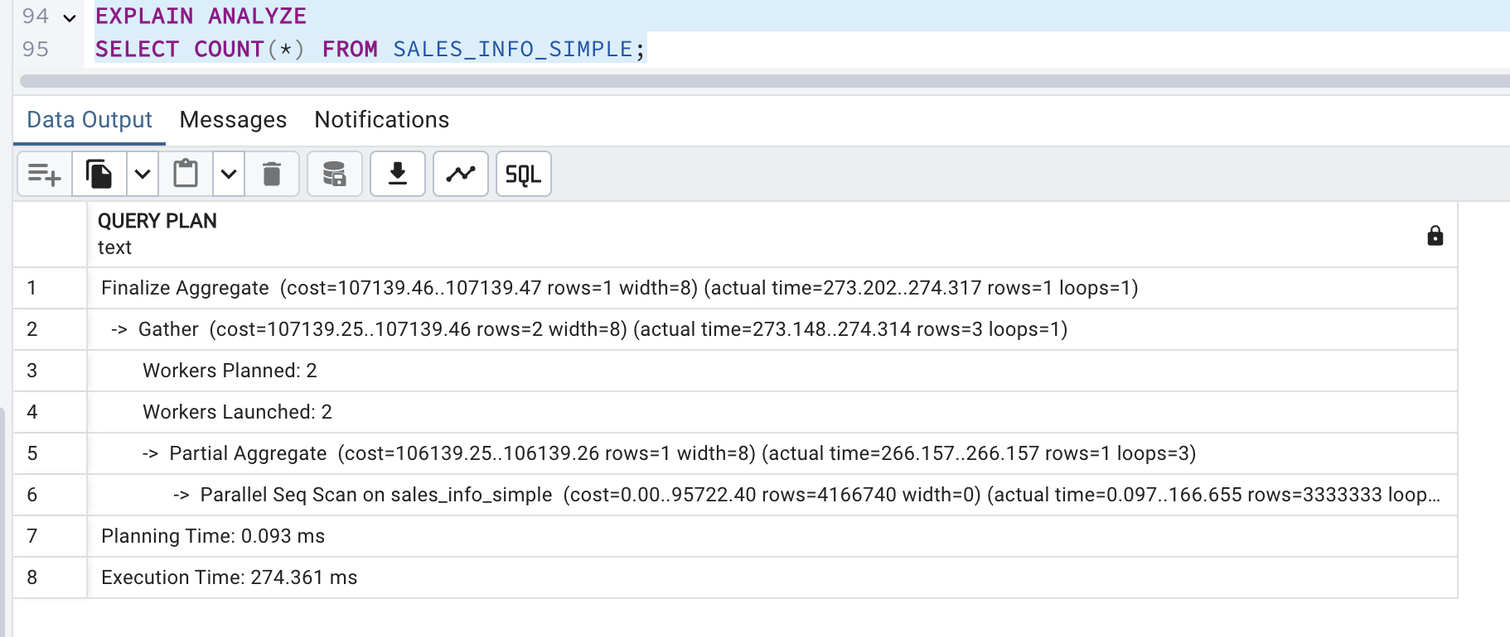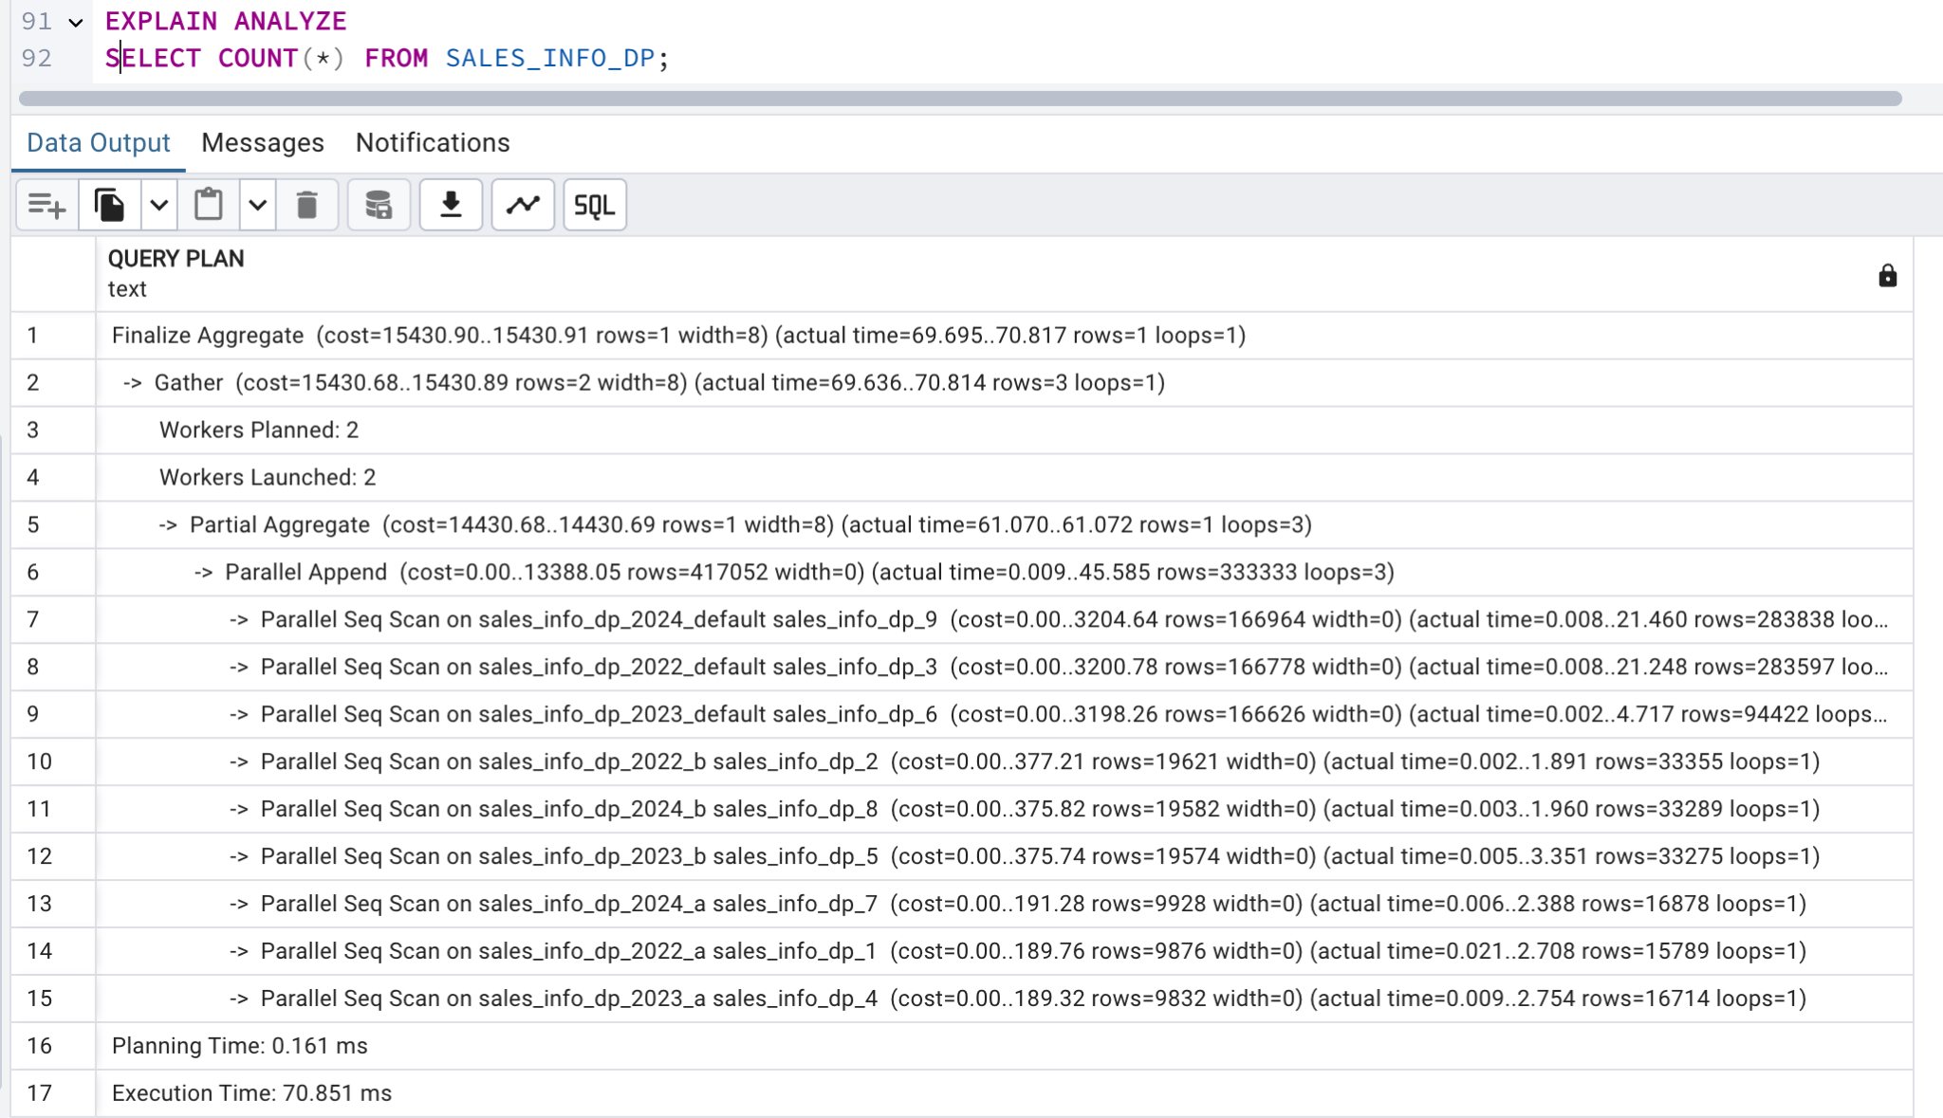

It shows that the partitioned uses parallel sequential scans across all partitions . In contrast, the non-partitioned table also performs a parallel sequential scan but takes less time. Even though partitioning, the overhead of scanning multiple partitions can lead to longer execution times compared to a single sequential scan for aggregate queries such as counting all row

**Count of Rows with Range of Dates**

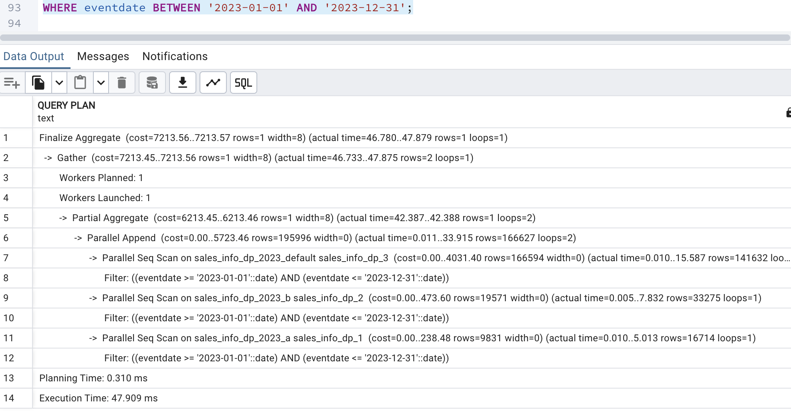

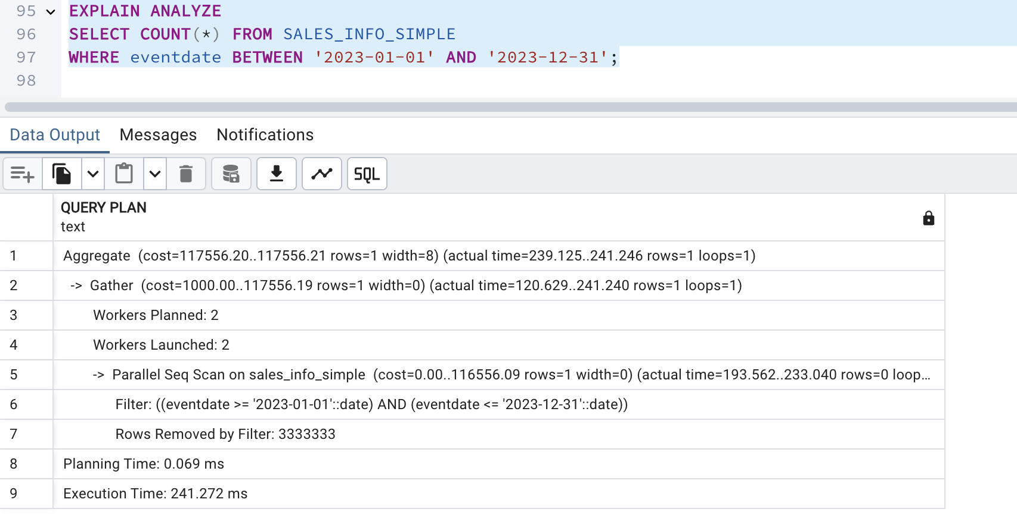

The COUNT(*) query shows that the partitioned table (SALES_INFO_DP) executes much faster compared to the non-partitioned table which takes 274.361 ms. The partitioned table processes smaller partitions in parallel, speeding up the aggregation. When, the non-partitioned table scans all rows in one large operation, leading to a significantly higher execution time

For one of the child tables with range partition by eventdate split one list partition for two: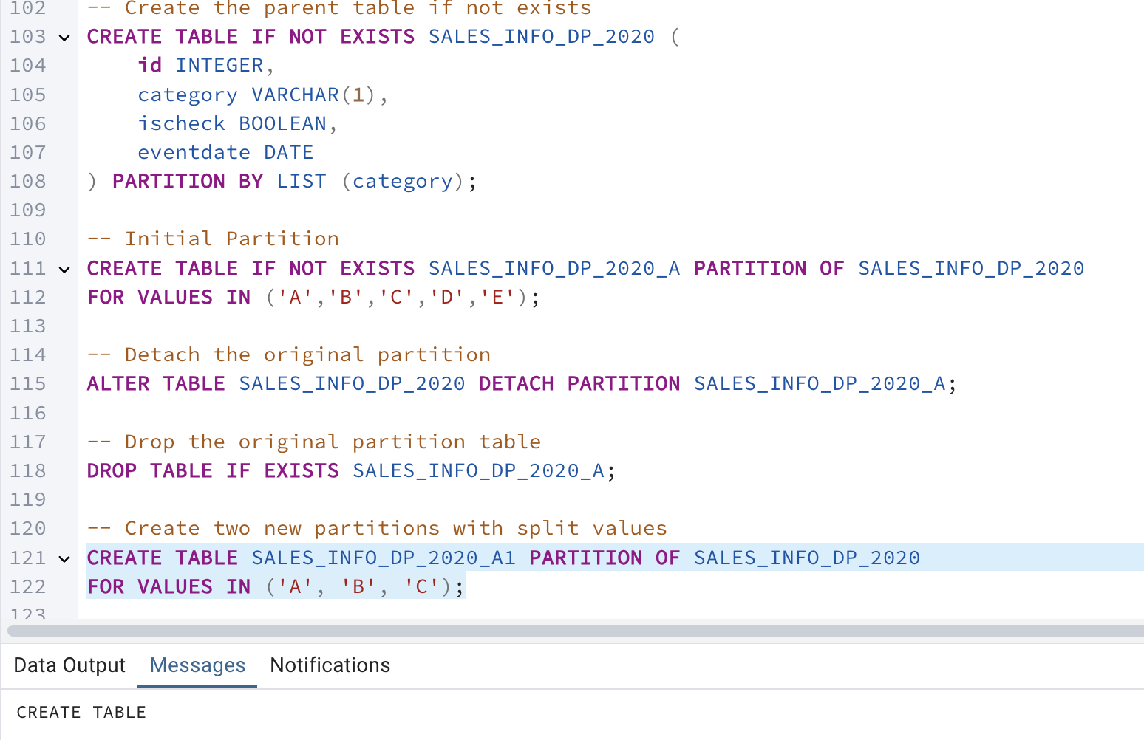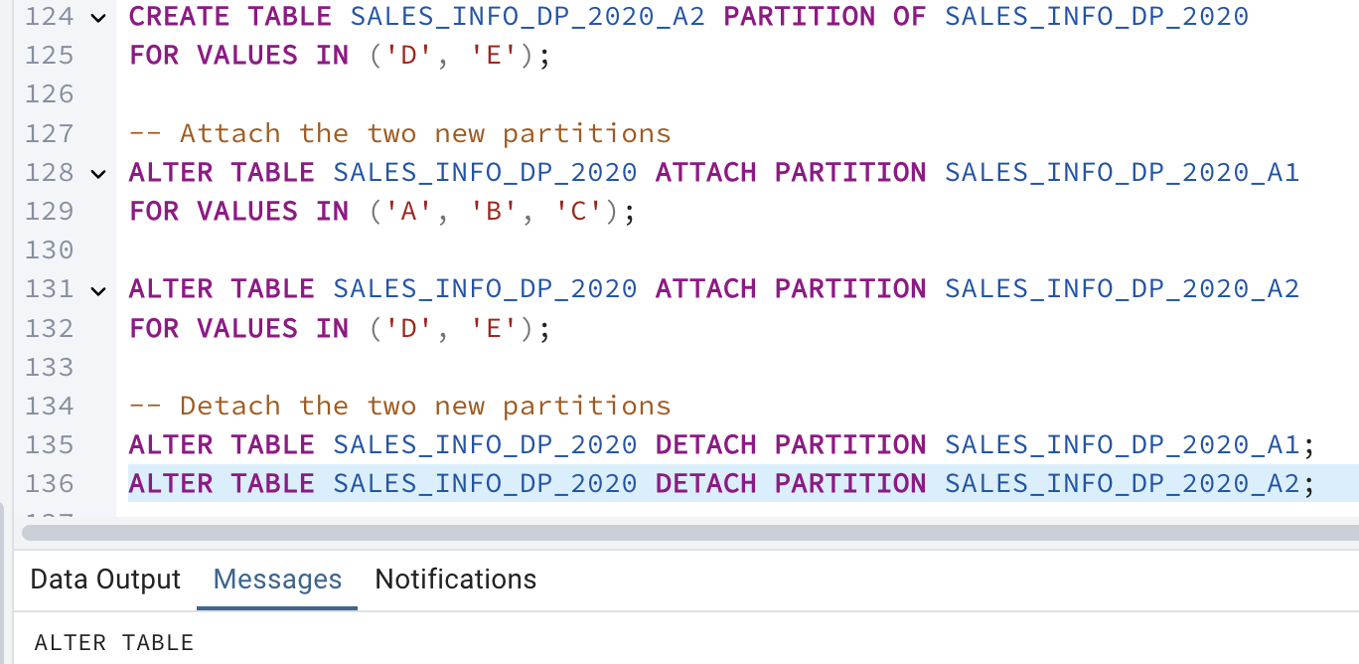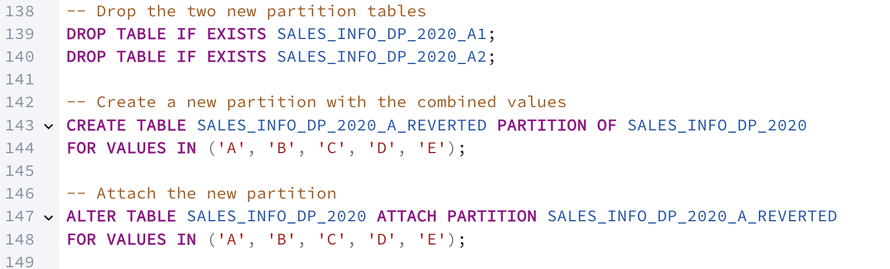

2.1 TASK 3: USE PARALLEL QUERING

a. Select all from tables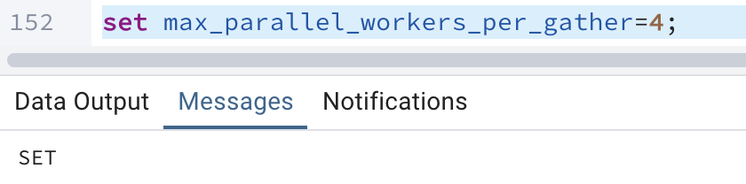

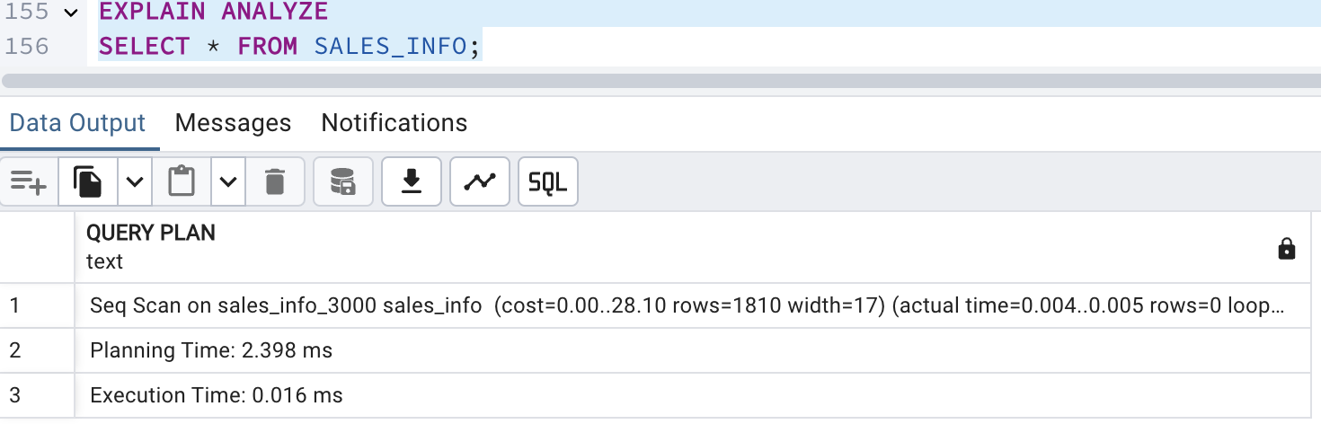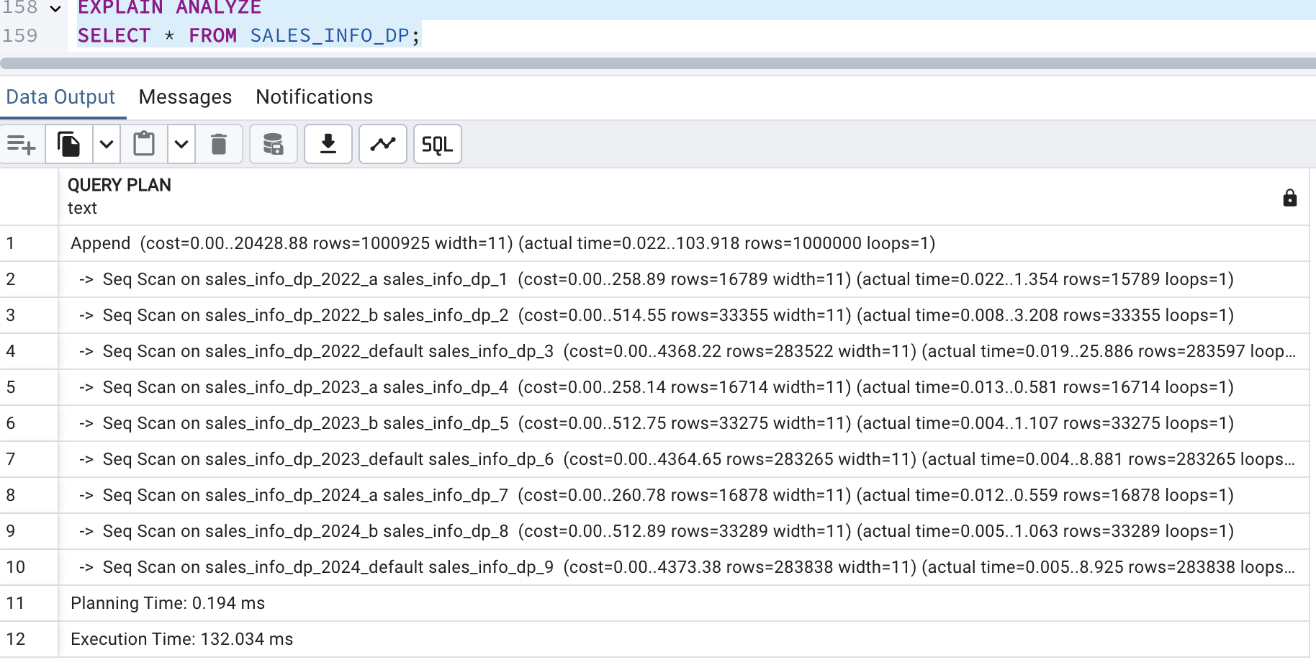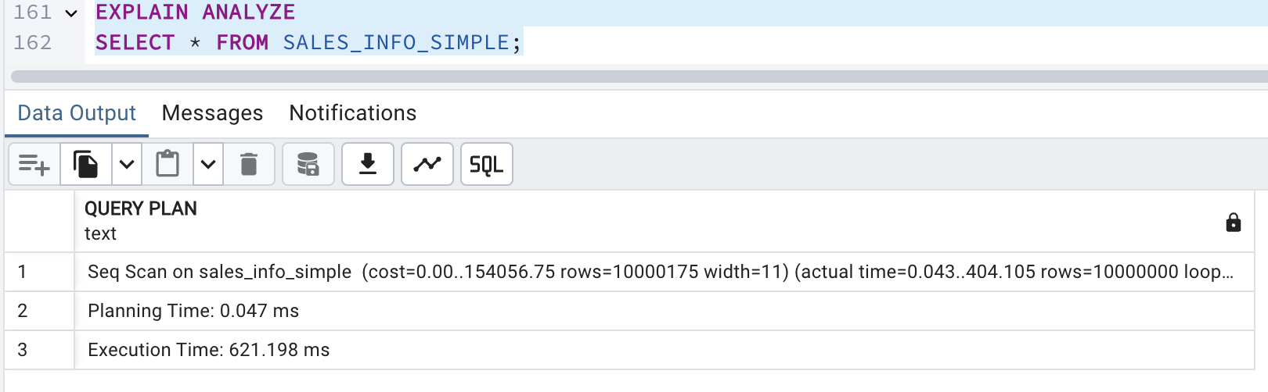

Both SALES_INFO and SALES_INFO_SIMPLE perform simple sequential scans. SALES_INFO is very fast because it has only a small number of rows.SALES_INFO_SIMPLE has nearly 10 million rows, so a full scan takes much longer.Despite partitioning, the execution time is shorter than SALES_INFO_SIMPLE but longer than SALES_INFO due to the extra overhead of scanning partitions. SALES_INFO is the fastest due to its small size. SALES_INFO_SIMPLE is slower than SALES_INFO but still faster than SALES_INFO_DP because it avoids partitioning overhead.

b. Add order by eventdate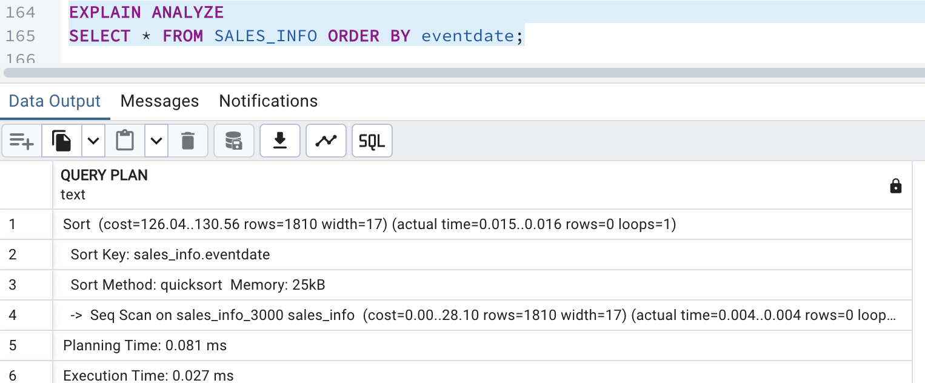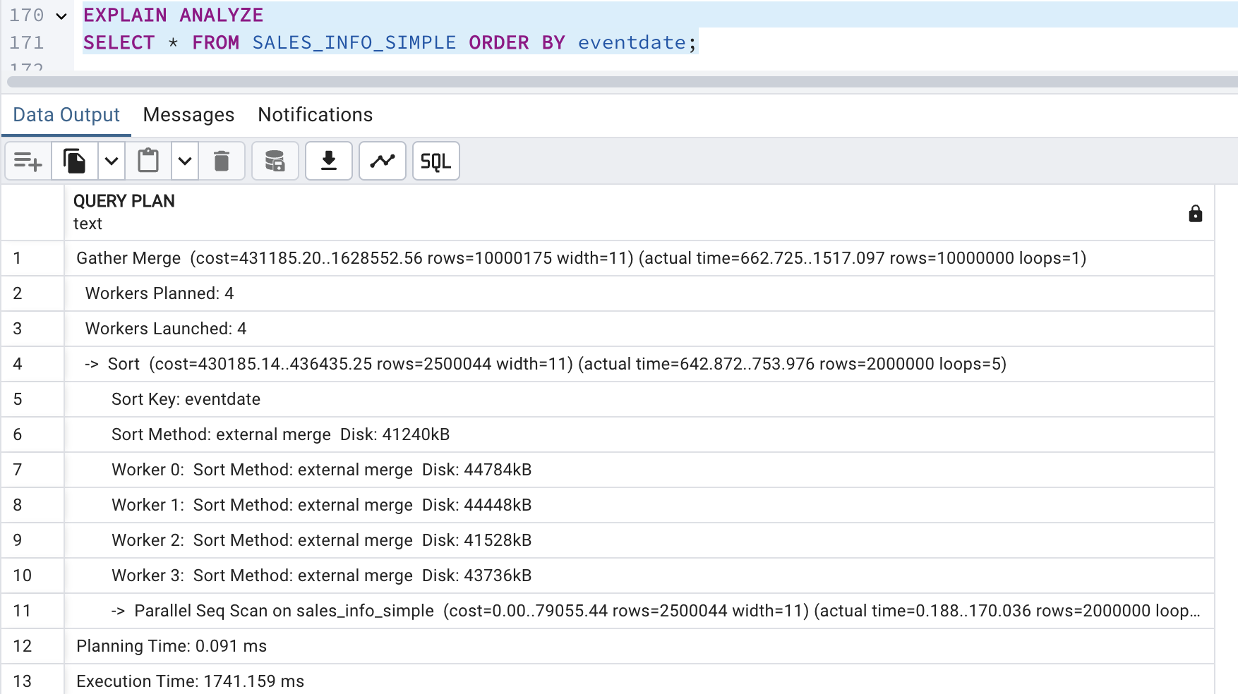

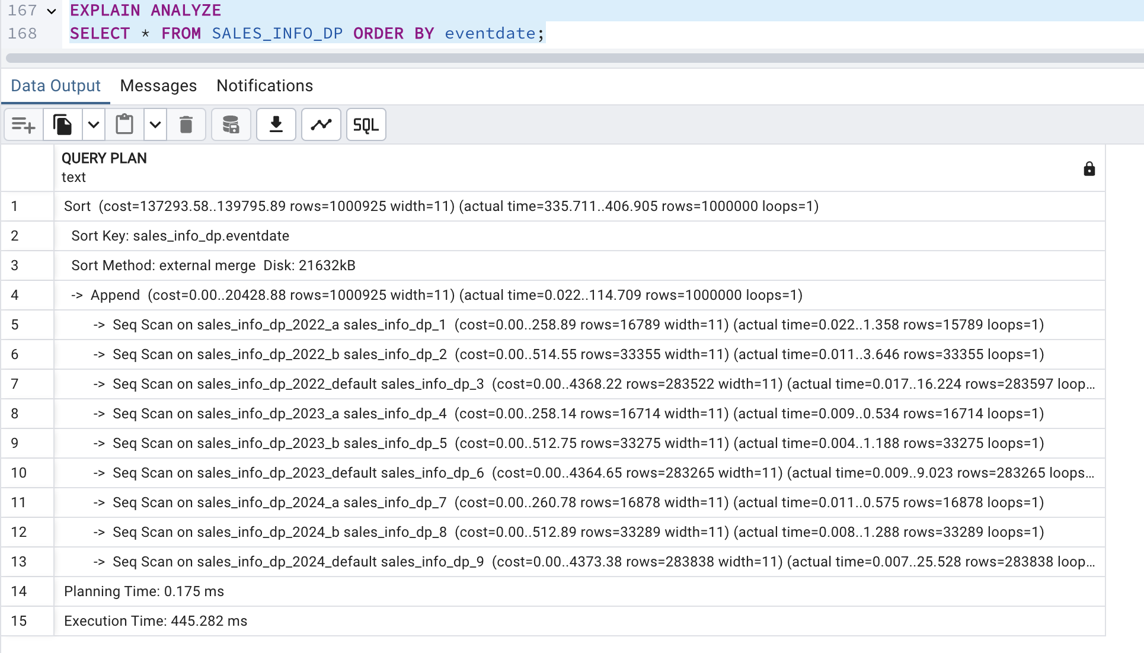

The SALES_INFO table performs a simple sequential scan followed by sorting, resulting in low execution time due to fewer rows.

The SALES_INFO_DP (partitioned table) executes multiple parallel sequential scans across partitions and uses a Gather Merge for sorting, increasing execution time due to partition management overhead.

The SALES_INFO_SIMPLE table uses parallel sequential scans and a Gather Merge, improving sorting efficiency compared to the partitioned table. However, due to handling a much larger dataset, its execution time is still significantly higher than SALES_INFO.

This shows that partitioning adds complexity but is beneficial for filtered queries, while sorting large datasets remains costly regardless of partitioning.

Select count of all rows

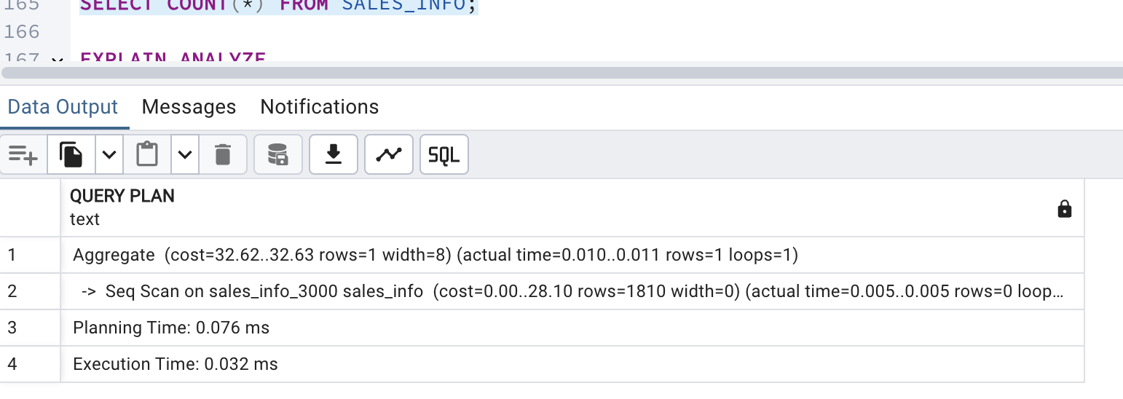

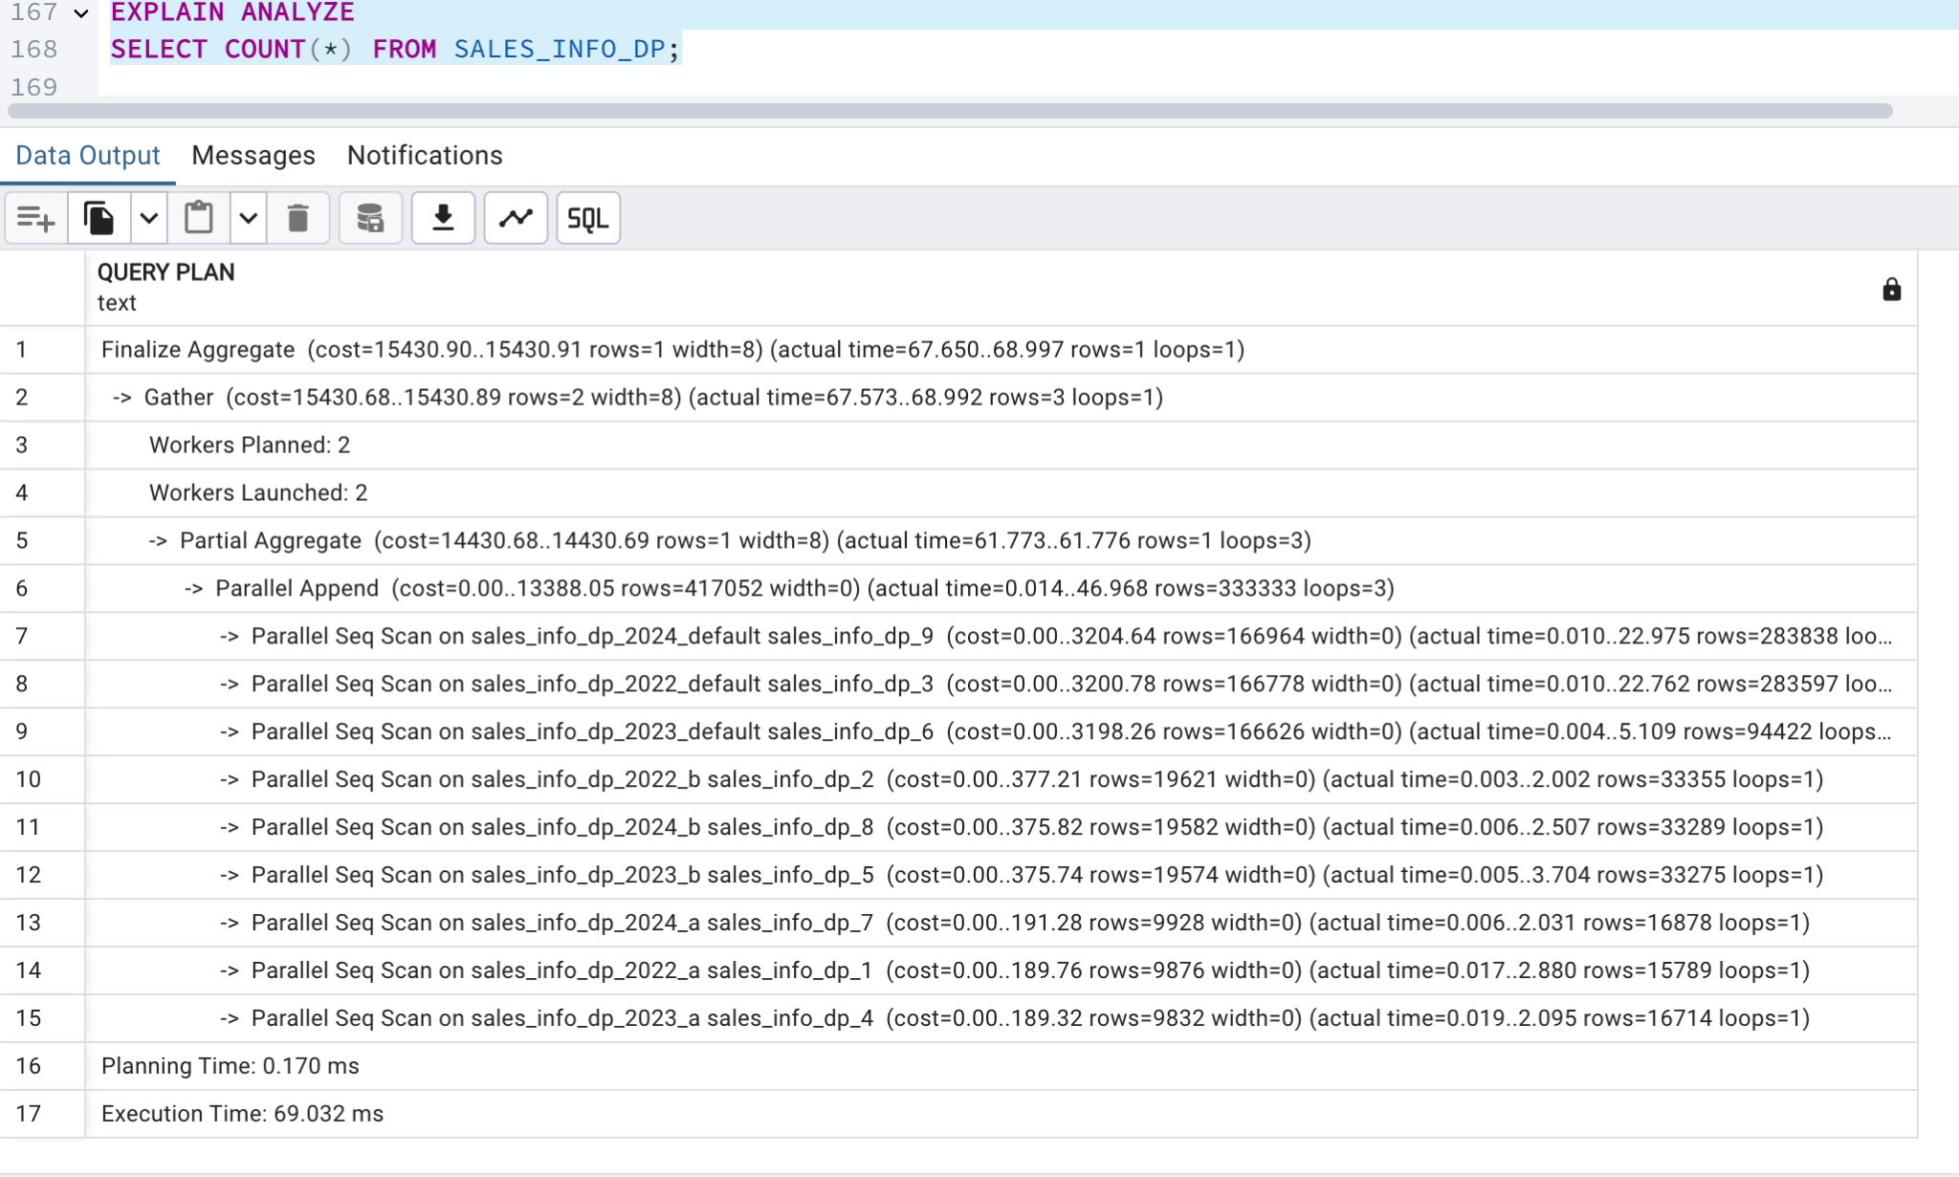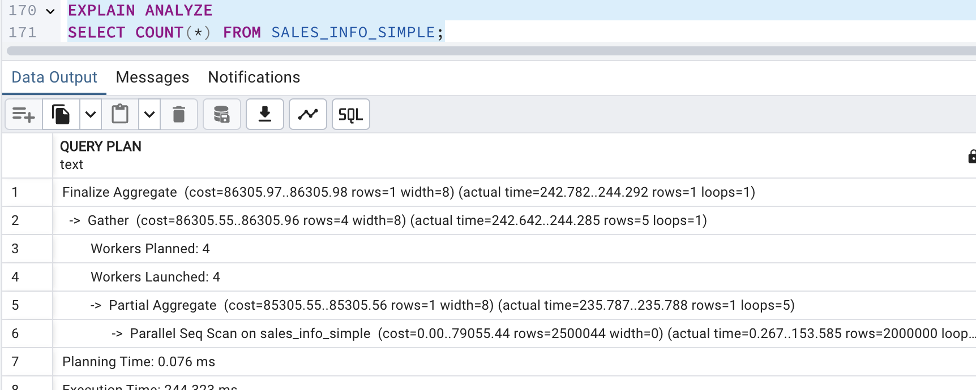

The SALES_INFO table performs a simple sequential scan followed by aggregation, resulting in very low execution time due to having fewer rows.

The SALES_INFO_DP (p table) uses parallel sequential scans across multiple partitions before aggregation, leading to a moderate execution time. The overhead of managing multiple partitions and merging results increases execution time.

The SALES_INFO_SIMPLE table uses parallel sequential scans and aggregation, handling a large number of rows more efficiently than the partitioned table. Due to the sheer volume of data, its execution time remains significantly high.

-- d. Add range of dates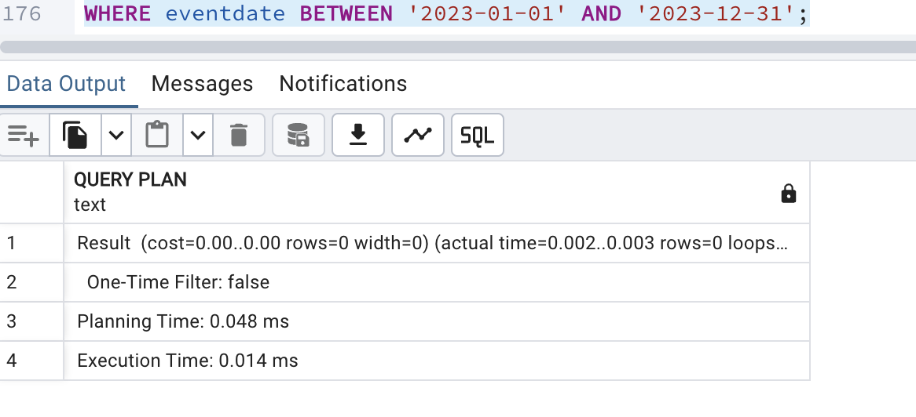

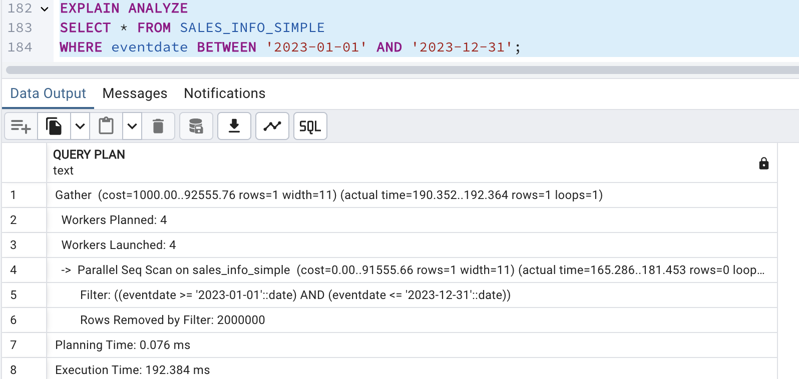

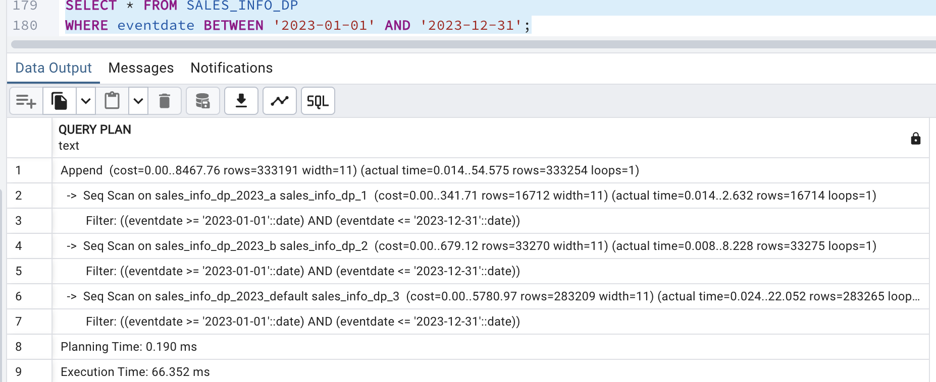

Partitioned Table (SALES_INFO_DP) is effective for range queries due to partition pruning. However, the Append operation and multiple sequential scans increase execution time (6.852 ms).

Non-Partitioned Table (SALES_INFO_SIMPLE) uses parallel execution, avoiding partition management overhead, making it faster for range queries but still slower than partition pruning (192.384 ms).

SALES_INFO has negligible execution time because it contains fewer rows and does not need filtering

-- e. Add grouping by category

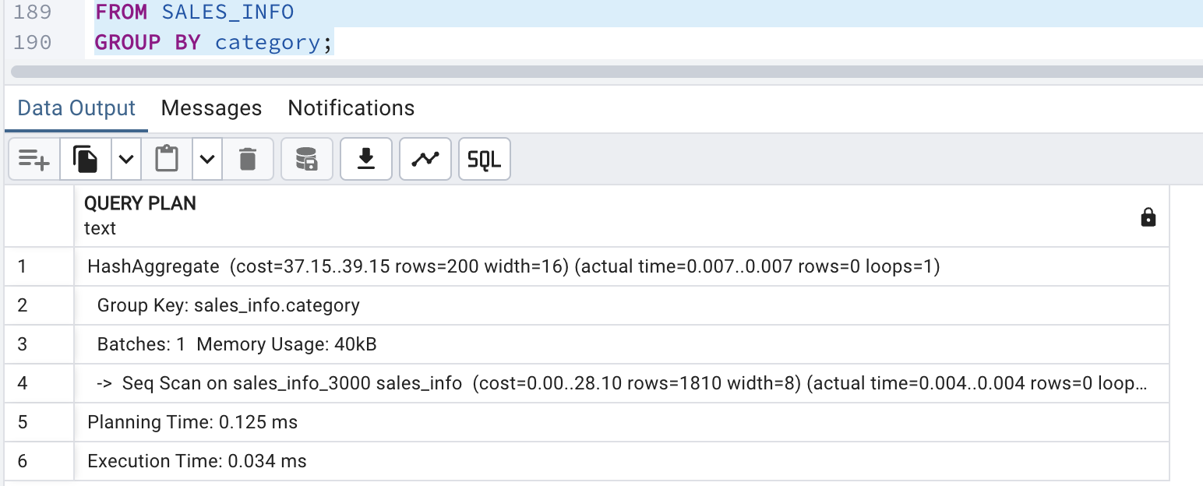

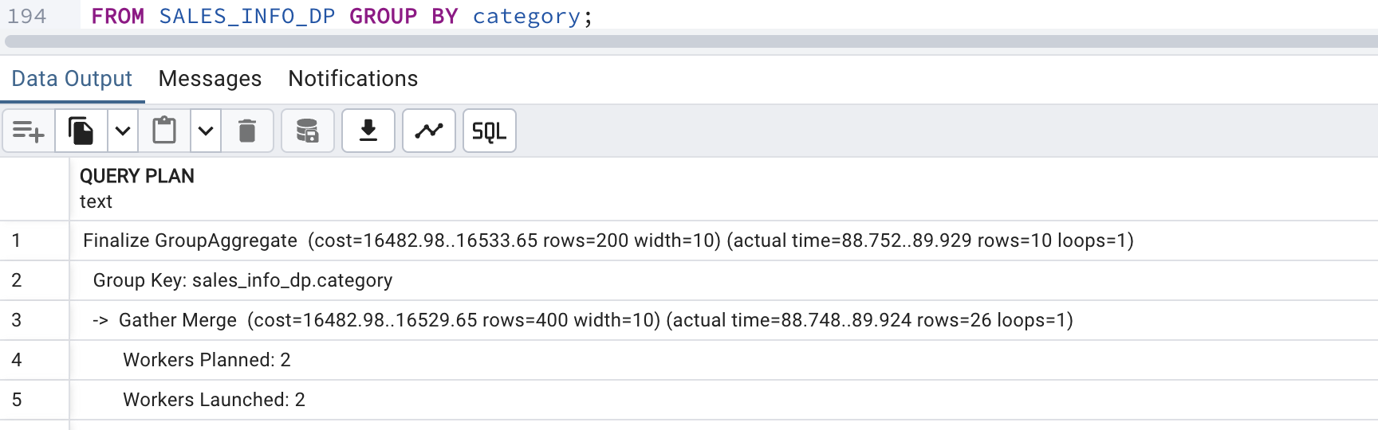

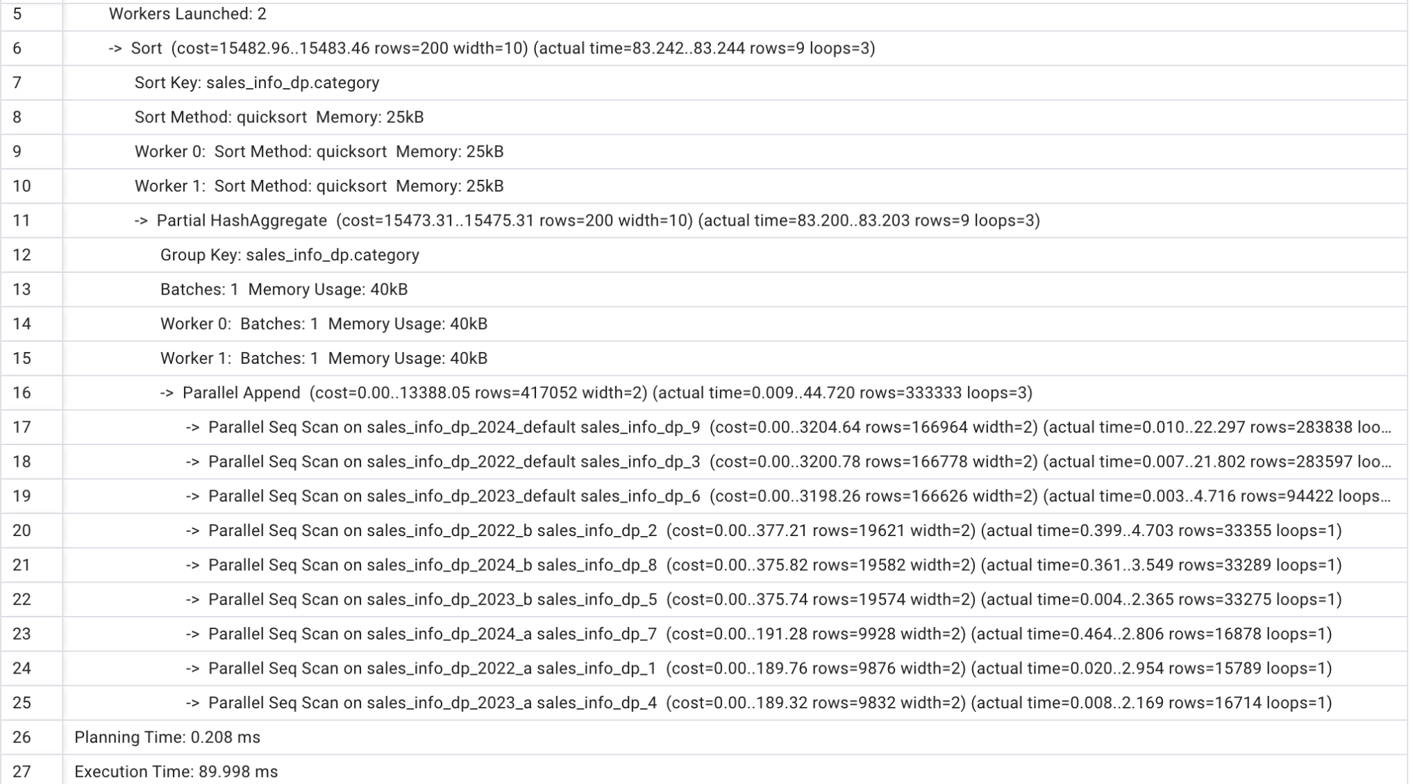

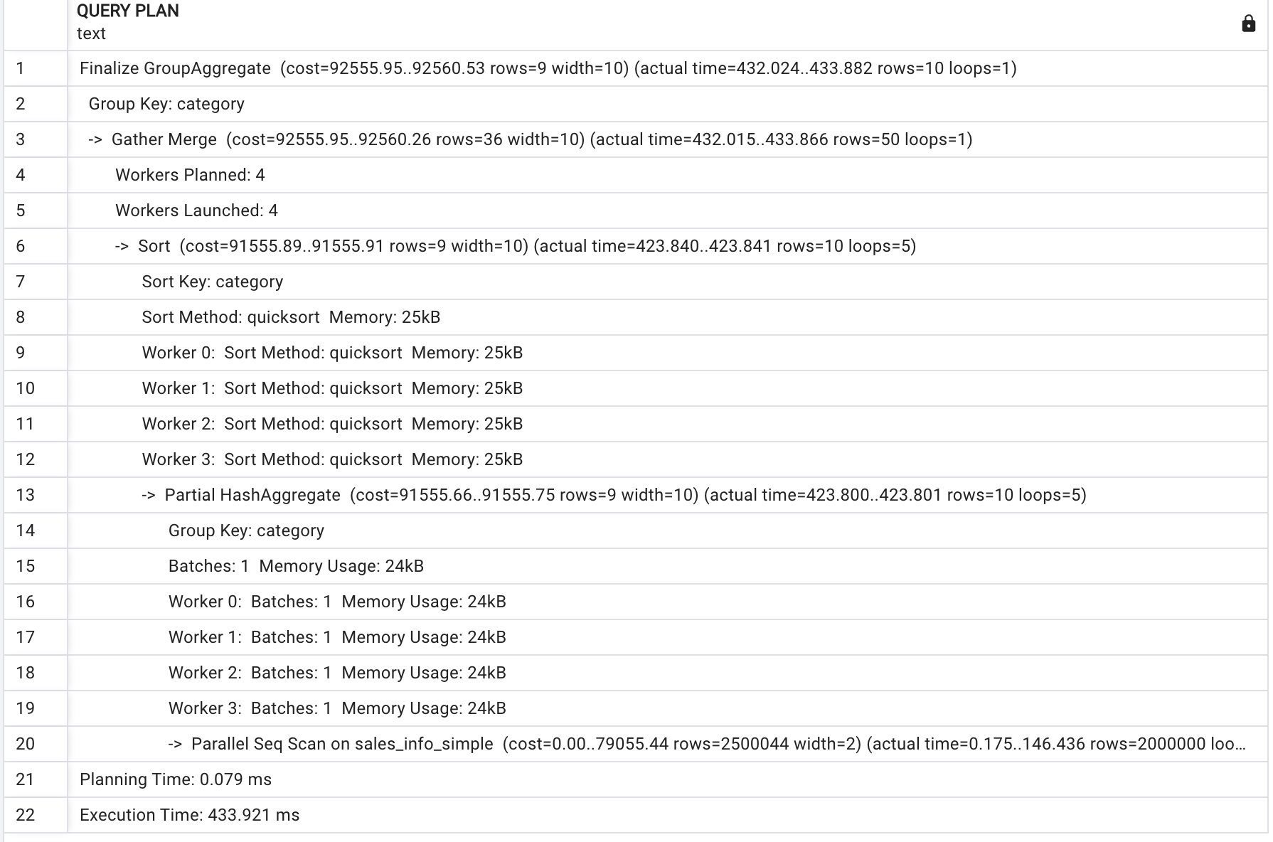

SALES_INFO executes the fastest because it performs a simple sequential scan followed by a hash aggregate on category, with very low execution time due to fewer rows.

SALES_INFO_DP (partitioned table) scans multiple partitions in parallel, then sorts and aggregates the results, leading to a higher execution time.

SALES_INFO_SIMPLE uses parallel sequential scans followed by sorting and aggregation, which performs better than the partitioned table since it avoids partition management overhead. Processes more rows, it remains faster than SALES_INFO_DP due to efficient parallel execution.

- f. Join SALES_INFO and SALES_INFO_DP on id and count rows on exact date

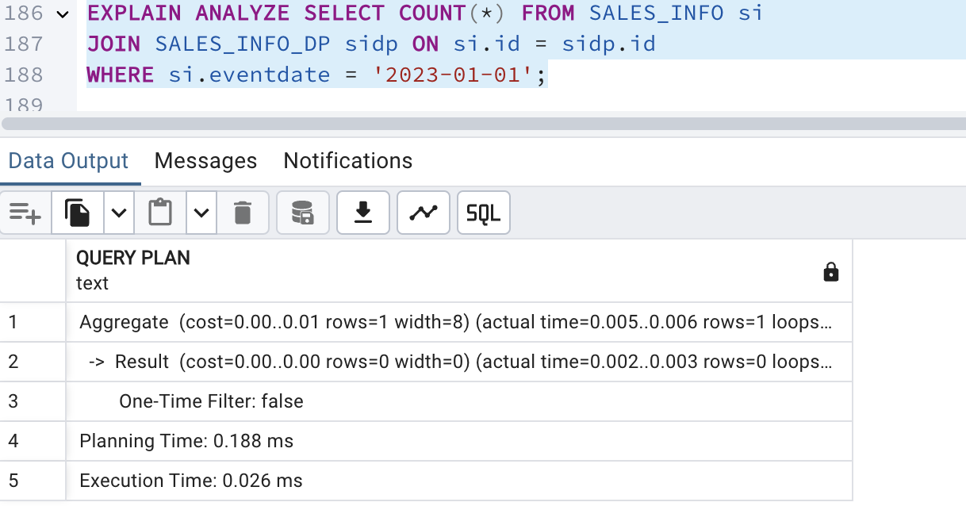

The query plan shows parallel processing with 3 workers allocated and launched.The join operation uses a parallel hash join along with parallel sequential scans on SALES_INFO_DP partitions.

A hash join is used, which is efficient for large datasets.

The filter on eventdate is applied to SALES_INFO first, reducing the number of rows before joining.

Now creating index on id and event date on table Sales_INFO_DP

Selecting all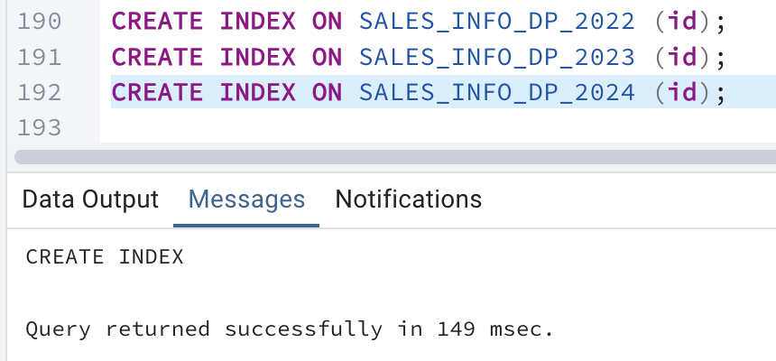

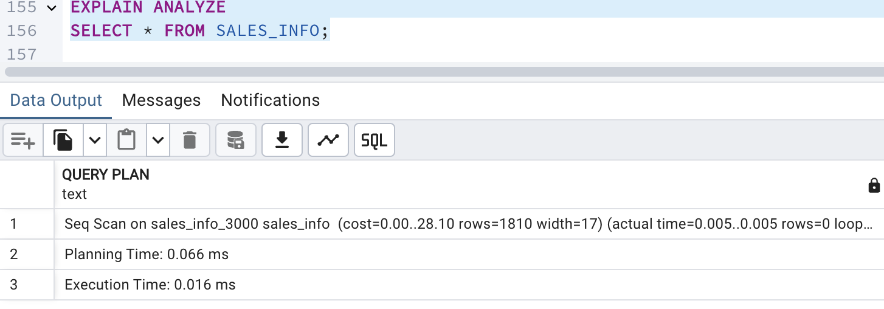

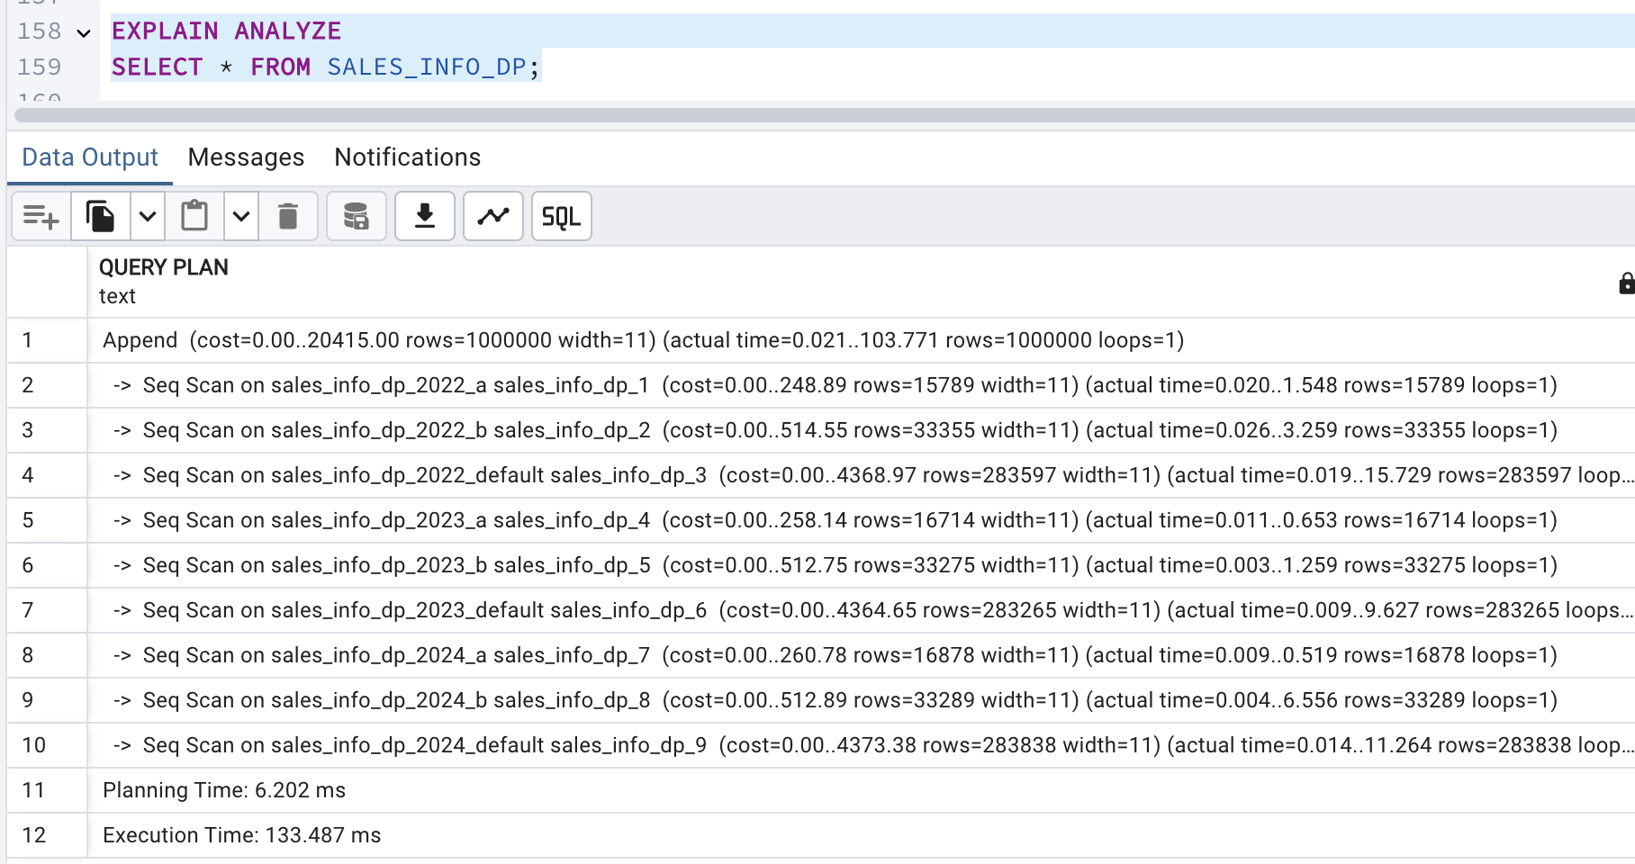

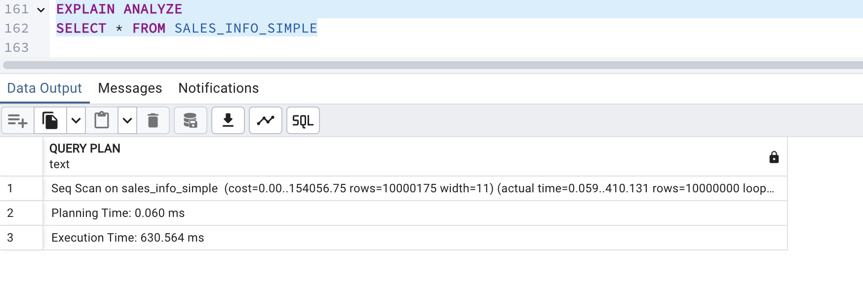

The SELECT * queries do not show significant improvements with the added indexes, as expected. Full table scans are still required for these queries. The modest improvement in SALES_INFO_DP suggests some behind-the-scenes optimization, but overall, the impact is minimal.

Order by eventdate

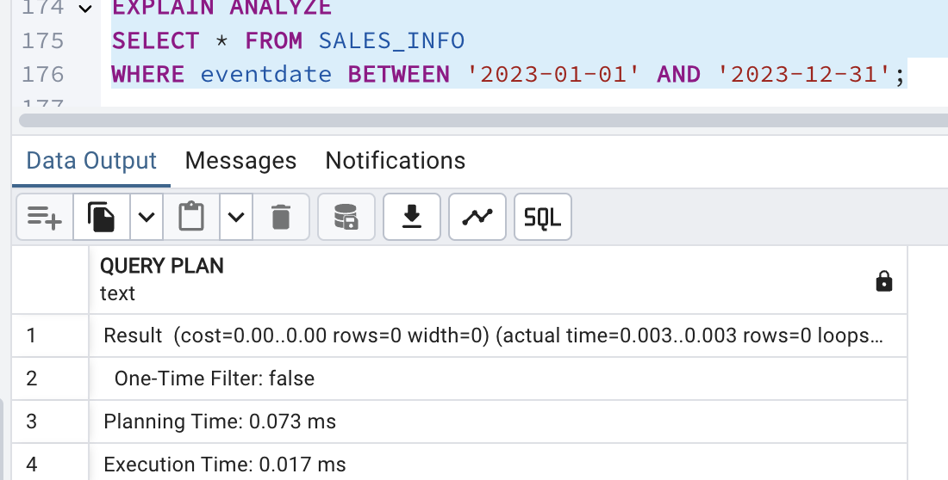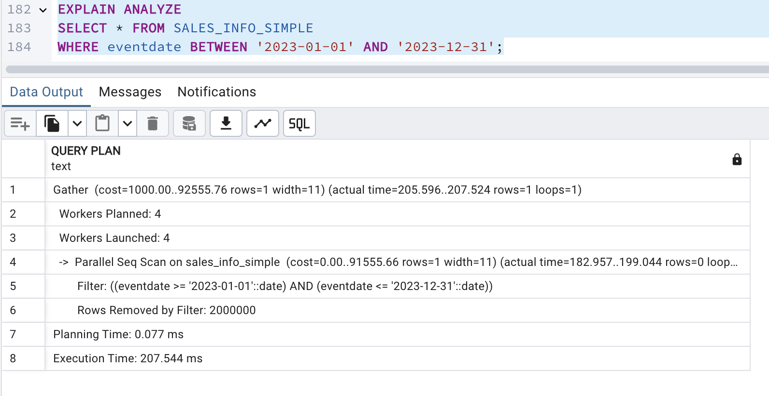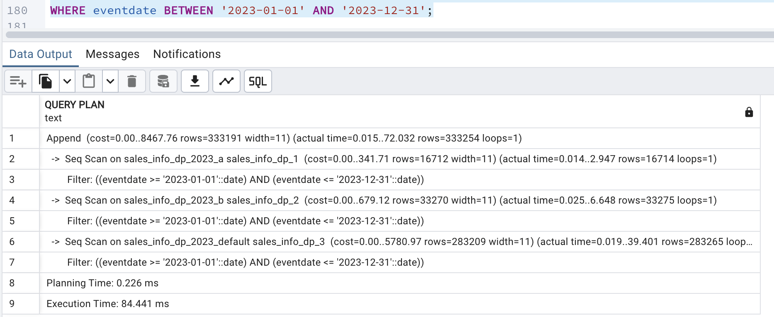

For SALES_INFO_DP, the execution time increased due to the complexity of managing index scans and merge append operations across partitions

Count all rows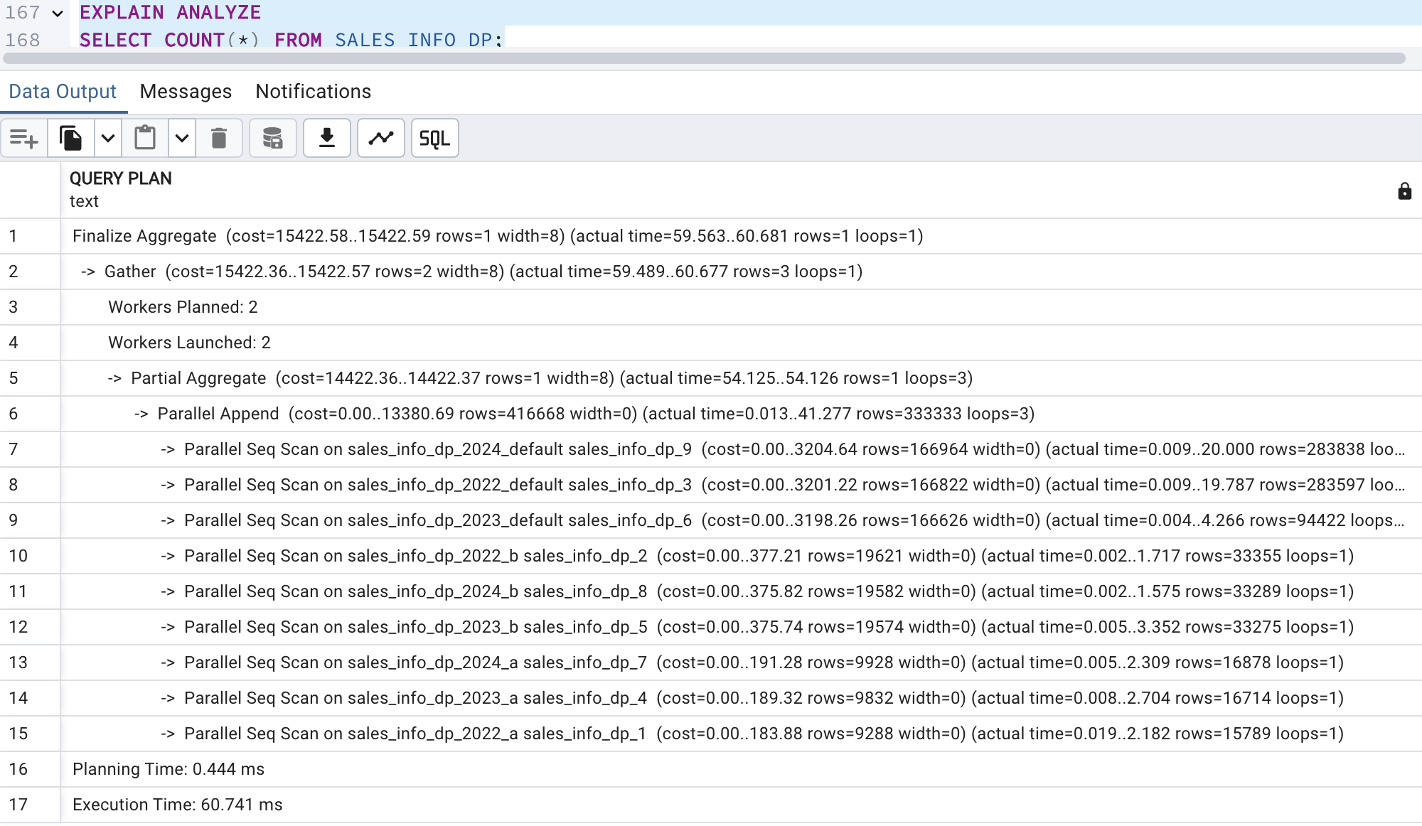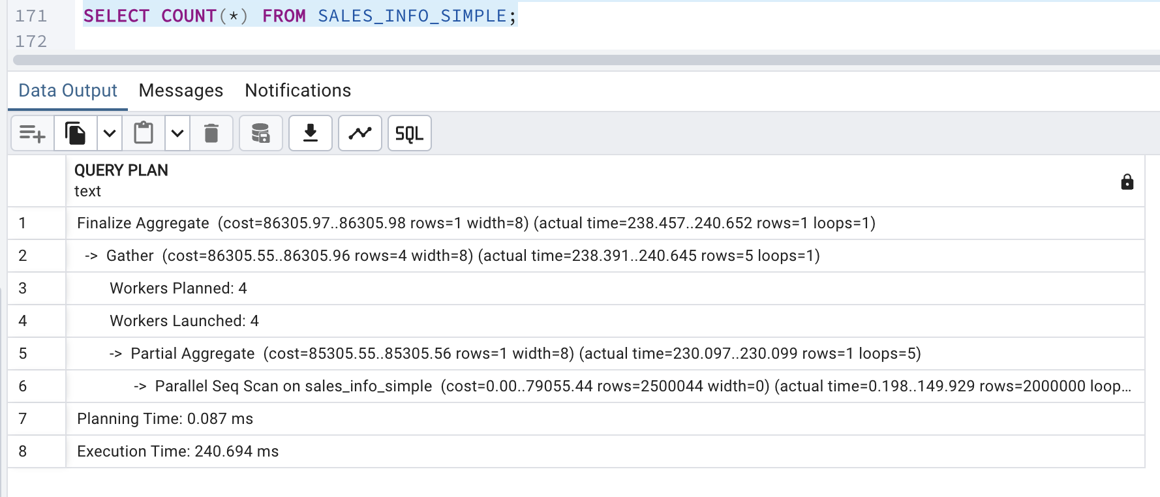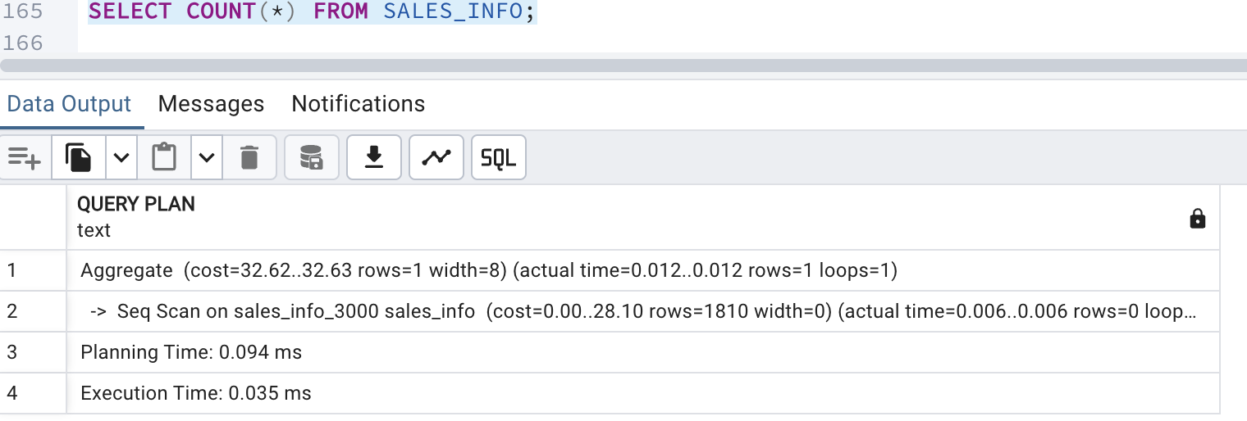

The COUNT(*) queries do not show significant improvements with the added indexes. Full table scans are still required for these queries.The modest changes in execution time indicate that the indexes may not provide significant benefits for simple aggregation queries like COUNT(*).

Add grouping by category

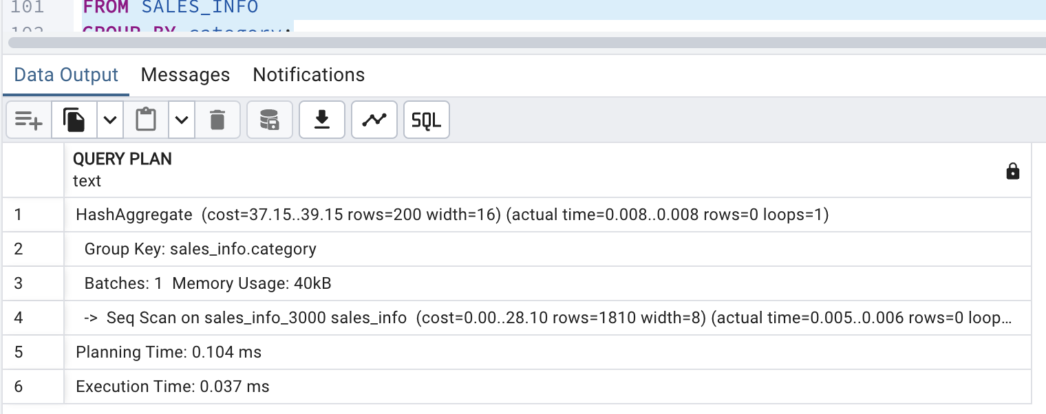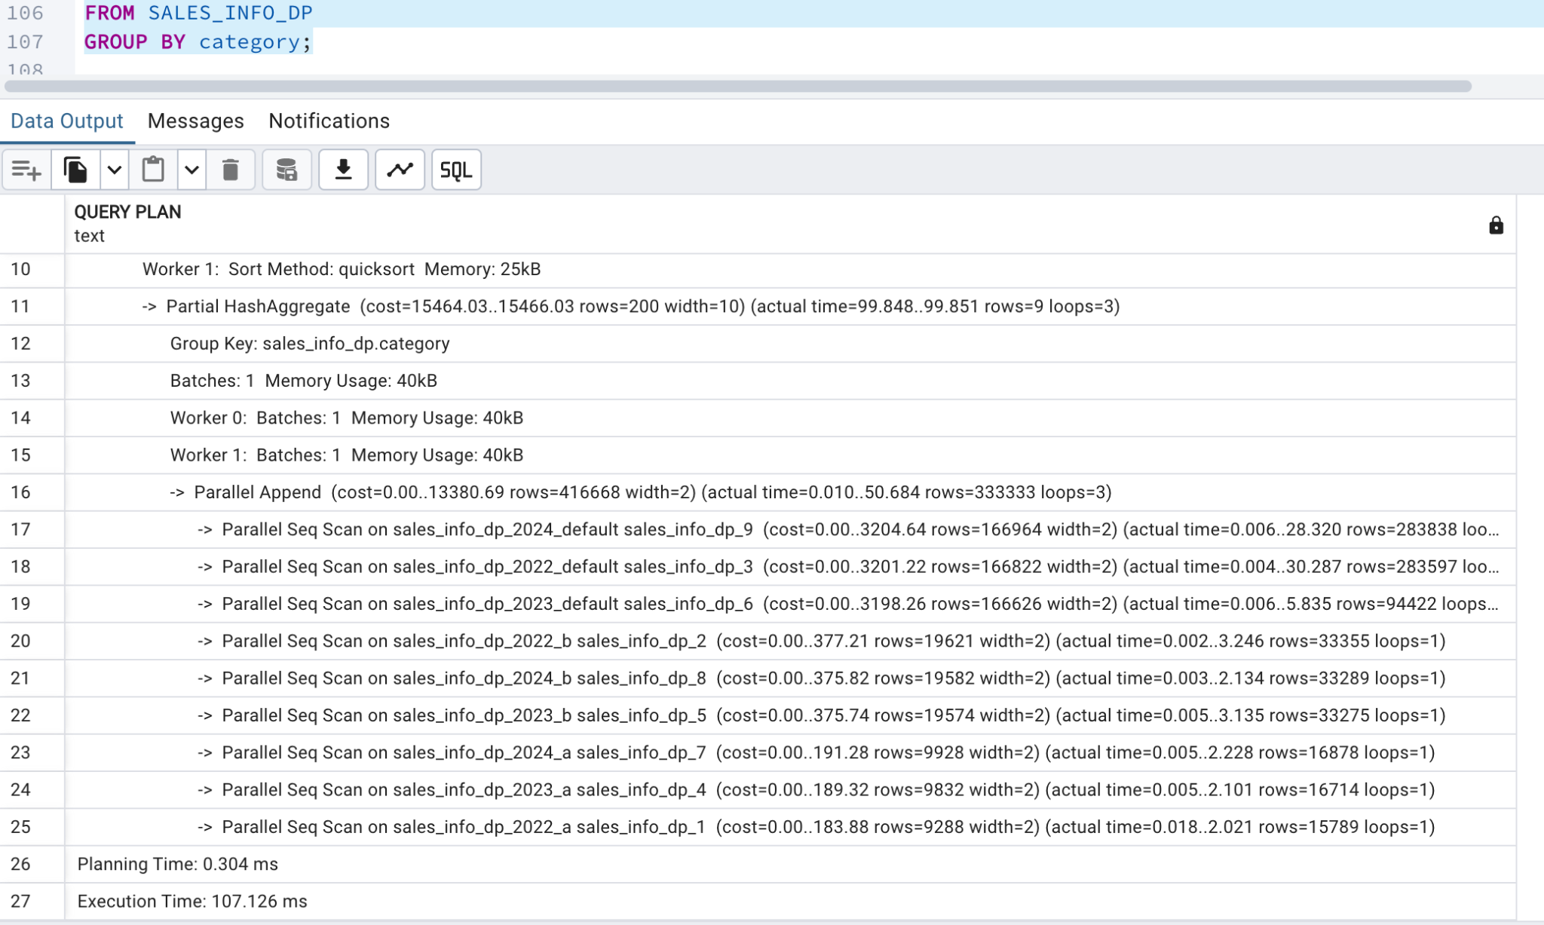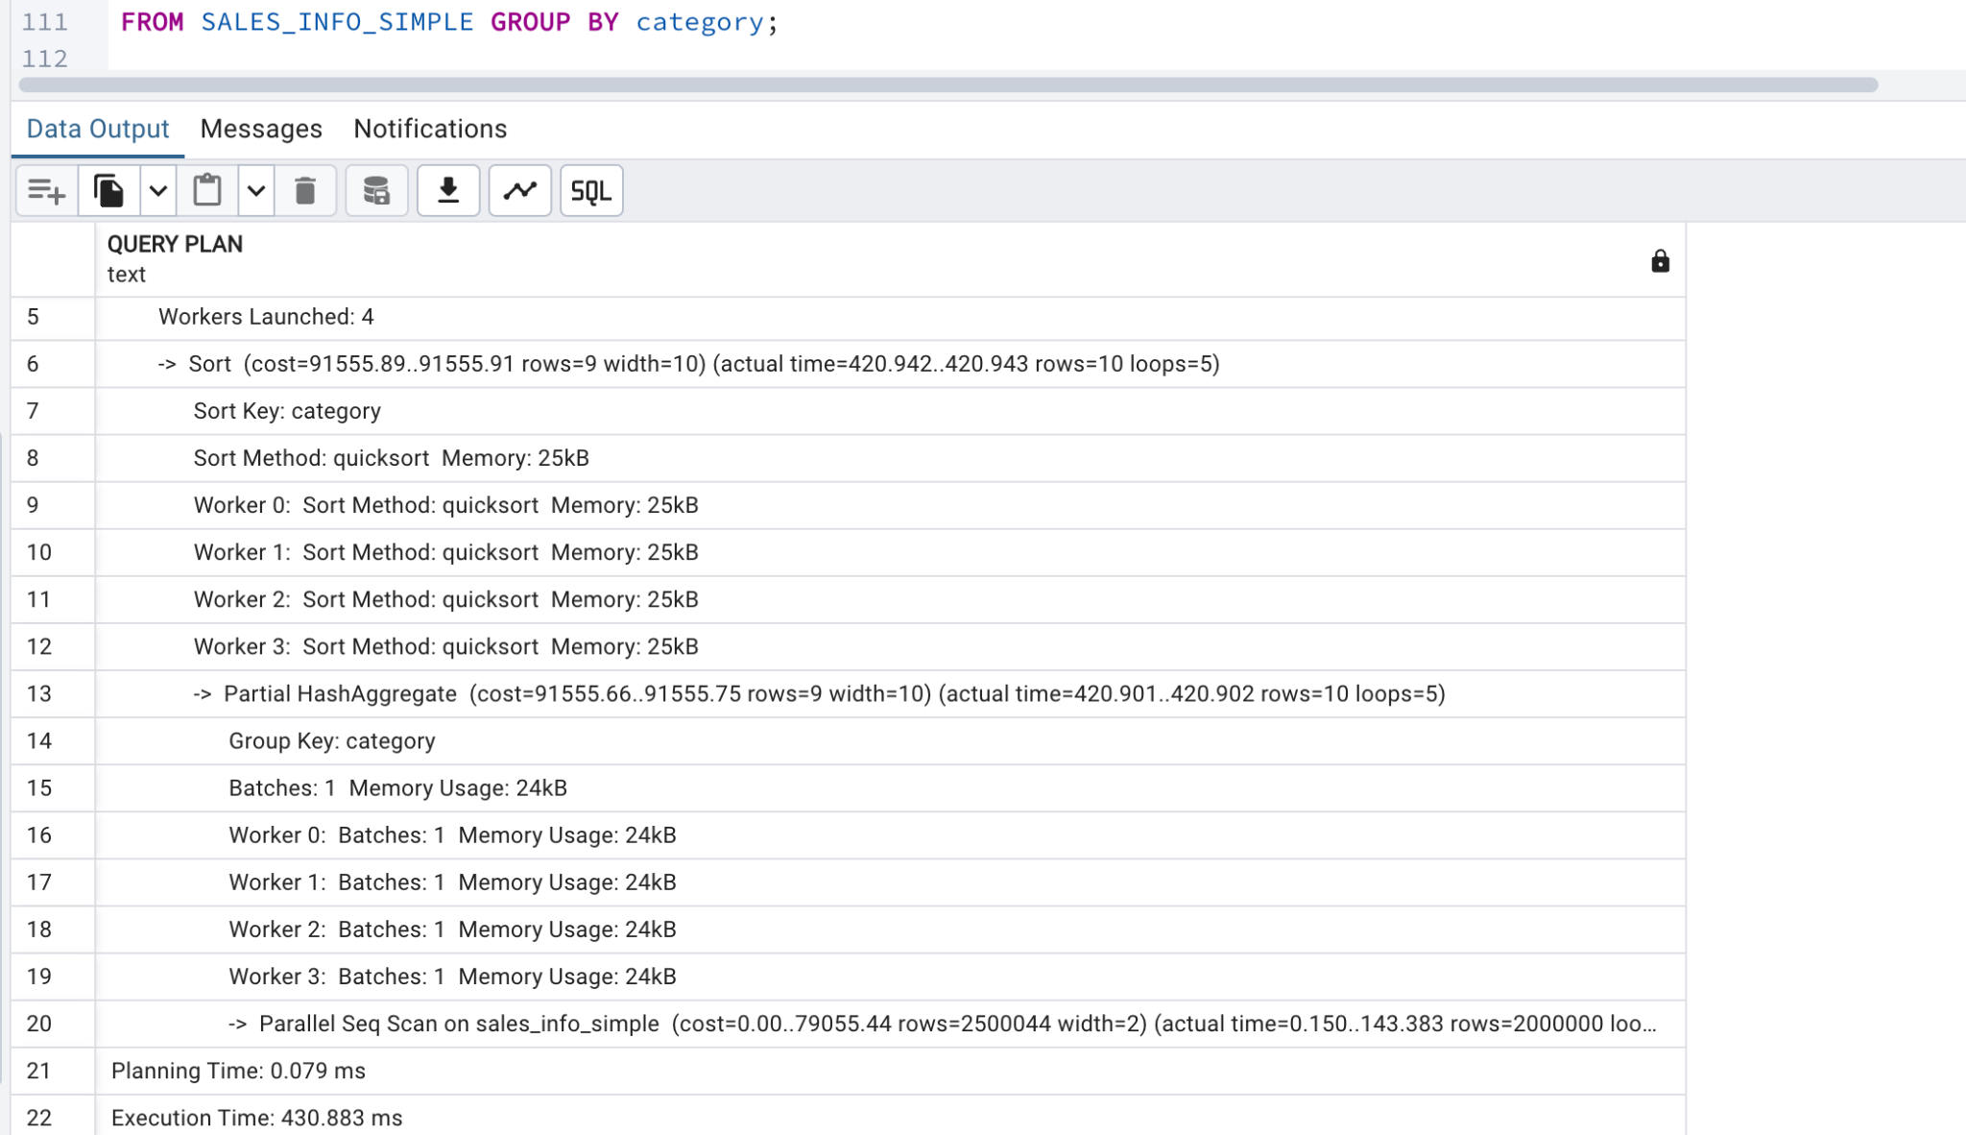

The execution time for SALES_INFO_DP increased slightly after adding the index. This suggests that the index does not significantly improve performance for the GROUP BY operation in this specific query. The overhead of maintaining and managing the index during aggregation may have contributed to the increased execution time.